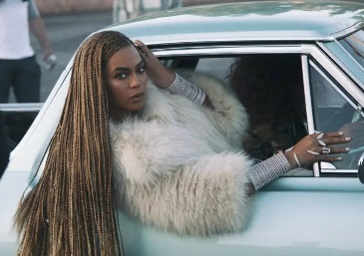
A Level Media Studies

COMPONENT 1 MEDIA PRODUCTS, AUDIENCES AND INDUSTRIES
Section A: Media Language and Representation
You will study set texts from the following industries: Advertising, Music Video and newspapers
Set Texts:
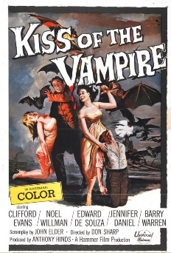
- Advertising: Tide print advertisement, Kiss of the Vampire film poster, Water Aid TV advert
- Music Video: Beyonce Formation, Vance Joy Riptide
- Newspaper: The Daily Mirror, The Times
Section B: Understanding Media Industries and Audiences
You will learn about the media industry and how media products target audiences through the study of the following texts:
- Advertising: Tide, Kiss of the Vampire
- Newspaper: The Daily Mirror, The Times
- Videogames: Assassin’s Creed Franchise
- Radio: Late Night Woman’s Hour
- Film Industry: I, Daniel Blake,Black Panther
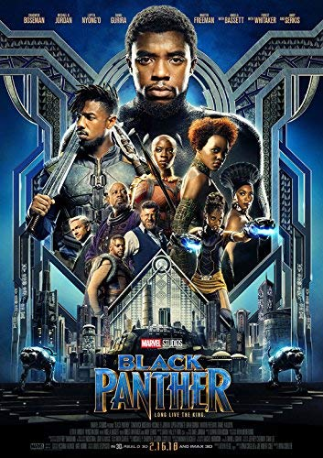

COMPONENT 2 Media Forms and Products in Depth
Section A: Television in the Global Age
You will explore two TV drama programmes from different countries:
- The Bridge (Sweden/Denmark)
- Life of Mars (UK)
Section B: Magazines: Mainstream and Alternative Media
You will explore magazines from different time periods that appeal to different audiences:
- Woman’s Realm
- Huck
Section C: Media in the Online Age
You will explore two contrasting online media products
- Zoella blog
- Attitude online magazine
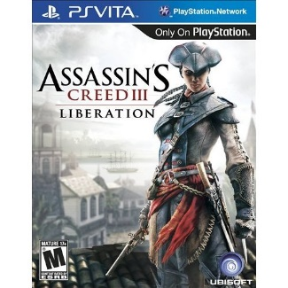

COMPONENT 3 NON-EXAMINED ASSESSMENT:
You will be required to produce an individual portfolio of media products to a set brief. Briefs are selected from the following media forms:
- Television
- Advertising and Marketing: Music
- Advertising and Marketing: Film
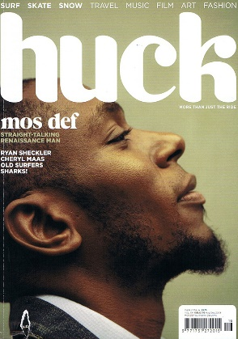
- Magazines
- Website Production

