Media Representations and Stereotypes

Below are a range of stereotypes that are associated with different Nations from around the world, the Media use these stereotypes as a visual short-cut for audience which help create a particular representation or understanding.

Task – look at each statement and write a brief sentence explaining where you have seen this stereotype used in The Media. The first one is done for you:

- Americans are often represented as obese, lazy, and dim-witted people who live on fast food and doughnuts.
- Homer Simpson from The Simpsons and Peter Griffin from Family Guy are personifications of this stereotype.

- Commonly used stereotypes suggest that Arab nations and Muslims are cruel, barbarous terrorists and have extreme attitudes to beliefs they do not share with others.

- Stereotypes suggest that Italian people are very family oriented, experts at cooking and very fashionable.

- People from African nations should be pitied because they stereotypically live in poverty and lack a basic standard of living.

- Americans are stereotypically friendly, generous, and tolerant, but also arrogant, successful, and domineering; particularly white American men who are commonly seen to be wealthy, racist and sexist.

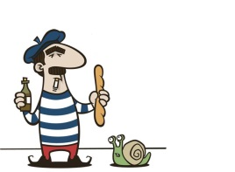
Media Representations and Stereotypes

Terminology | Definition
Connotation

Stereotype

Archetype

Countertype

Realism

Myth

Cultural Stereotyping | Ideas are created about a specific culture or traditional cultural stereotypes are used.
Mainstream
Marginalization

