Tragedy Reading List – A-Level English Literature
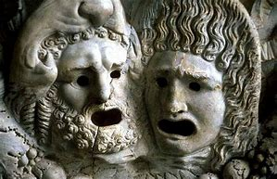
Below is a suggested list of a variety of tragedies from Ancient Greek to modern which also cover a span of types and aspects of tragedies. The list contains prose, poetry and plays for you to choose from. When you have read a text from the list, make notes on the elements of tragedy it contains and the sub-genre it belongs to using the link below as a useful starting point. We will talk about your thoughts on these during the first week of the course, so make sure to bring this list and your notes with you. Enjoy!
https://www.englishandmedia.co.uk/assets/uploads/preview_files/Tragedy.pdf
Suggested reading list for Tragedy:
Aeschylus - Oresteia
Aristotle - Poetics
Emily Brontë – Wuthering Heights
Robert Browning – Porphyria’s Lover and others
Anton Chekhov – Uncle Vanya
Caryl Churchill – Top Girls
Emily Dickinson – various poems
Euripedes – The Bacchae
F. Scott Fitzgerald – The Great Gatsby
Thomas Hardy - Tess of the d’Urbervilles
Thomas Hardy – various poems
Henrik Ibsen – Hedda Gabler
Kazuo Ishiguro – The Remains of the Day
Christopher Marlowe – Dr Faustus
Arthur Miller - A View From The Bridge
Arthur Miller - The Crucible
Toni Morrison – Beloved
Sylvia Plath – various poems
William Shakespeare – Hamlet
William Shakespeare – King Lear
Sophocles – Antigone
Tennessee Williams – A Streetcar Named Desire

