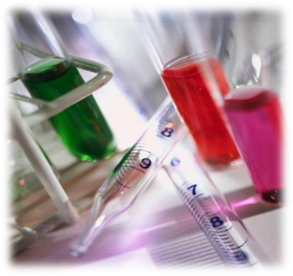

Transition Pack for Applied Science

Get ready for BTEC L3!
A guide to help you get ready for the Applied Science (and Science part of the Forensics) course.

Adapted from the The PiXL Club Ltd. A level resources

for the BTEC L3 courses by MF, May 2020

This resource is strictly for the use of member schools for as long as they remain members of The PiXL Club. It may not be copied, sold nor transferred to a third party or used by the school after membership ceases. Until such time it may be freely used within the member school.

All opinions and contributions are those of the authors. The contents of this resource are not connected with nor endorsed by any other company, organisation or institution. www.pixl.org.uk The PiXL Club Ltd, Company number 07321607

So, you are considering the BTEC L3 Applied Science and/or Forensics and Criminology course

This pack contains a programme of activities and resources to prepare you to start L3 Applied Science and/or the science part of the Forensics course in September. It is aimed to be used after you complete your GCSEs throughout the remainder of the summer term and over the summer holidays to ensure you are ready to start your course in September.
Year 12:
Unit 1 – Principles of Science
- Chemistry: Periodicity and properties of elements
- Biology: Structure and functions of cells and tissues
- Physics: Waves in communication
Assessment: 3x 40 min exams in year 12

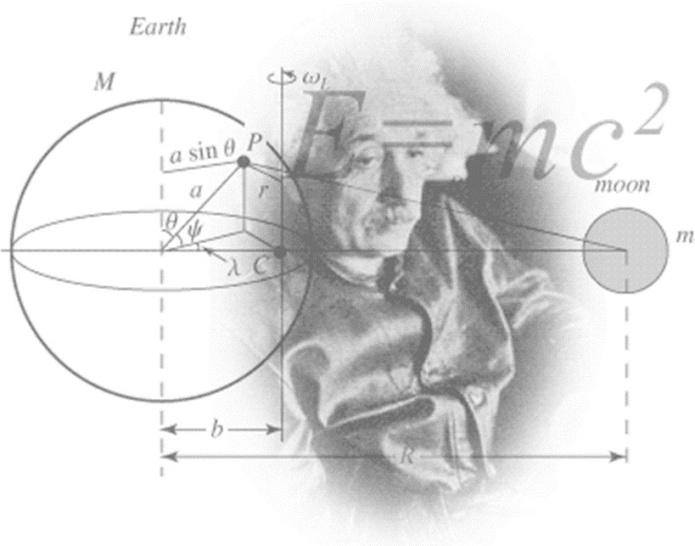
Year 12:
Unit 2 - Practical Scientific Procedures and techniques

Assessment: 4 assignments

Figure 1 http://scienceworld.wolfram.com/physics/images/main-physics.gif

Kick back this summer with a good read. The books below are all popular science books and great for extending your understanding of Biology, Chemistry, Physics and Forensics.

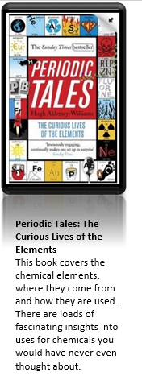
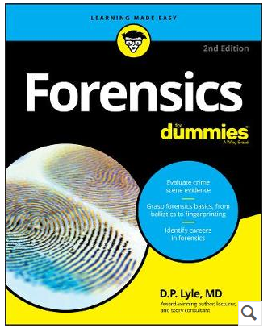

Understand the real-life science behind crime scene investigation:
Forensics For Dummies takes you inside the world of crime scene investigation to give you the low down on this exciting field. Written by a doctor and former Law & Order consultant, this guide will have you solving crimes along with your favorite TV shows in no time.

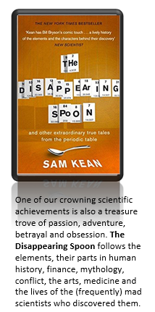

Everyone loves a good story. Here are some picks of the best films based on real life scientists and discoveries. Great watching for a rainy day.

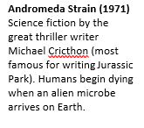
Silent Witness is a British television crime drama series, produced by the BBC, which focuses on a team of forensic pathology experts and their investigations into various crimes. On Iplayer.

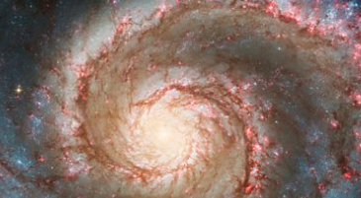
Hubble: The Wonders of Space Revealed
Horizon2020

To celebrate the 30th anniversary of its launch, this celebrates how a team of daring astronauts risked their lives to keep this remarkable telescope working.
On Iplayer in May 2020

.

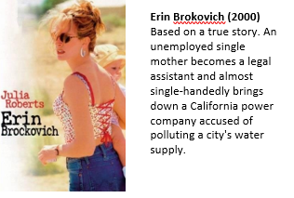

There are some great TV series and box sets available too! You might want to check out: Blue Planet, Planet Earth, Blackfish, Wonders of the Universe, Wonders of the Solar System, NASA TV and Shock & Awe – The Story of Electricity.

If you have 30 minutes to spare, here are some great presentations (and free!) from world leading scientists and researchers on a variety of topics. They provide some interesting answers and ask some thought-provoking questions. Use the link or scan the QR code to view:

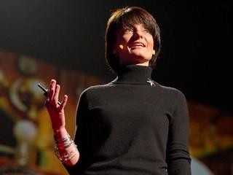
From mach-20 glider to hummingbird drone
Available at: https://www.ted.com/talks/regina_dugan_f rom_mach_20_glider_to_humming_bird_dr one/up-next?language=en
"What would you attempt to do if you knew you could not fail?" asks Regina Dugan, then director of DARPA, the Defense Advanced Research Projects Agency. In this talk, she describes some of the extraordinary projects that her agency has created.
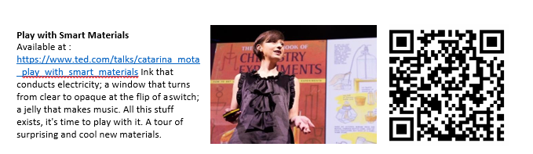
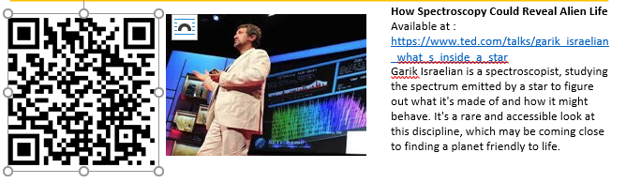

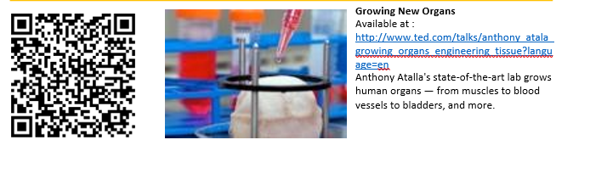

Research, reading and note making are essential skills for L3 Applied Science. For the
following tasks you are going to produce ‘Cornell Notes’ to summarise your reading.

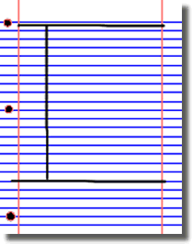
- Divide your page into three sections like this

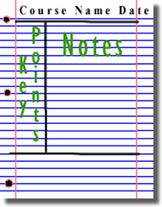
3. Use the large box to make notes. Leave a space between separate idea. Abbreviate where possible.

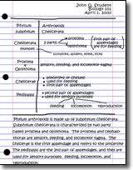
5. Write a summary of the main ideas in the bottom space
- Write the name, date and topic at the top of the page

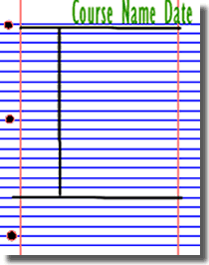
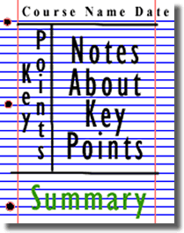
4. Review and identify the key points in the left hand box

Images taken from http://coe.jmu.edu/learningtoolbox/cornellnotes.html

TASK: Choose two of the following topics from the next three pages and use the resources to produce one page of Cornell style notes on each topic. There are some Biology, Chemistry and Physics options – take your pick.

CHEMISTRY
Aimed at students aged 14-19, Catalyst magazine is packed with interesting articles on cutting-edge science, interviews and new research written by leading academics. It also includes a booklet of teacher's notes, full of ideas and lesson plans to bring the articles to life in the classroom.

Use the links of scan the QR code to take you to the resources.

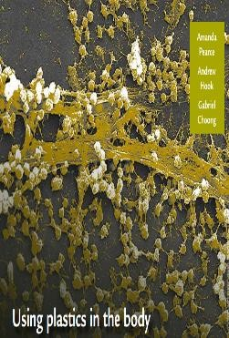
Topic 1: Using Plastics in the Body Available at:
https://www.stem.org.uk/resources/elibrary/resourc e/382317/using-plastics-body
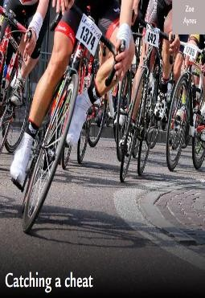
This Catalyst article looks at how scientists are learning to use polymers for many medical applications, including implants, bone repairs and reduction in infections.

Topic 2: Catching a Cheat Available at:
https://www.stem.org.uk/system/files/elibrary- resources/2017/03/Catching%20a%20cheat.pdf This Catalyst article looks at analytical chemists who are involved in many kinds of testing, including drug testing to catch cheats in sport.

BIOLOGY
The Big Picture is an excellent publication from the Wellcome Trust. Along with the magazine, the company produces posters, videos and other resources aimed at students studying for GCSEs and A level.

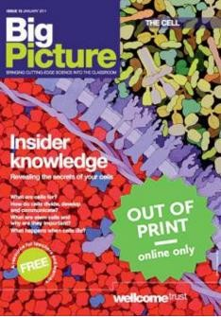
Topic 1: The Cell
Available at: http://bigpictureeducation.com/cell The cell is the building block of life. Each of us starts from a single cell, a zygote, and grows into a complex organism made of trillions of cells. In this issue, we
explore what we know – and what we don’t yet know
– about the cells that are the basis of us all and how they reproduce, grow, move, communicate and die.

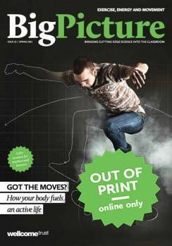
Topic 2: Exercise, Energy and Movement Available at: http://bigpictureeducation.com/exercise-energy- and-movement
All living things move. Whether it’s a plant growing towards the sun, bacteria swimming away from a toxin or you walking home, anything alive must move to survive. For humans though, movement is more than just survival – we move for fun, to compete and to be healthy. In this issue we look at the biological systems that keep us moving and consider some of the psychological, social and ethical aspects of exercise and sport.

PHYSICS
Physics provides daily online-only news and commentary about a selection of papers from the APS journal collection. The website is aimed at the reader who wants to keep up with highlights of physics research with explanations that don’t rely on jargon and technical detail.

Use the link or scan the QR code to take you to the resource.

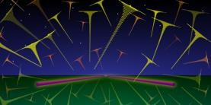
Topic 1: Listening for the cosmic hum of black holes

Available at: https://physics.aps.org/articles/v11/36

A new analysis technique would allow the gravitational-wave “background” from distant black hole mergers to be detected in days instead of years.

The Physics in this L3 course will develop GCSE knowledge and build on this to help you understand Unit 1C the Waves and Communication topic. Complete the following tasks to keep up to date and so you are ready to start studying:

Symbols and Prefixes

Prefix | Symbol | Power of ten
Nano | n | x 10-9
Micro | μ | x 10-6
Milli | m | x 10-3
Centi | c | x 10-2
Kilo | k | x 103
Mega | M | x 106
Giga | G | x 109

You need to remember these symbols, units and prefixes. Below is a list of quantities (some of which you may have already come across) which you will be using during your L3 course.

Quantity | Symbol | Unit
Velocity | v | ms-1
frequency | f | Hz
wavelength | λ | m
Time Period | T | s
Tension | T | N
Mass per unit length of string | µ | kg/m
Refractive index | n | N/A
Angle of incidence | i | ⁰
Angle of refraction | r | ⁰
speed of light in a vacuum | c | ms-1
speed of light in a medium | v | ms-1
Critical angle | C | ⁰
Intensity of a source | I | W/m2
Constant for a particular wave source | k
Radius from wave source | r | m

Task: Solve the following:

- How many metres in 2.4 km?
- How many joules in 8.1 MJ?
- Convert 326 GW into W.
- Convert 54 600 mm into m.
- How many grams in 240 kg?
- Convert 0.18 nm into m.
- Convert 632 nm into m. Express in standard form.
- Convert 1002 mV into V. Express in standard form.
- How many eV in 0.511 MeV? Express in standard form.
- How many m in 11 km? Express in standard form.

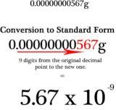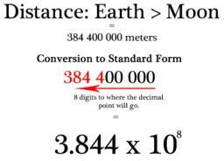Standard Form

In the L3 course, quantities will sometimes be written in standard form because the numbers are so large.

http://www.ultimatemaths.com/standard-form-conversion.htm

This means answers should be written as ….x 10y. E.g. for an answer of 1200kg we would write 1.2 x 103kg. For more information visit: www.bbc.co.uk/education/guides/zc2hsbk/revision

Task: Complete the following problems;

- Write 2530 in standard form.

- Write 280 in standard form.

- Write 0.77 in standard form.

- Write 0.0091 in standard form.

- Write 1 872 000 in standard form.
- Write 12.2 in standard form.
- Write 2.4 x 10 2 as a normal number.
- Write 3.505 x 10 1 as a normal number.
- Write 8.31 x 10 6 as a normal number.
- Write 6.002 x 10 2 as a normal number.

Rearranging Formulae

The good news that is that the 40 min Physics exam in Year 12 only requires the use of 6 formulae, 5 of which are given on the exam paper! Yippee. You have rearranged formulae at GCSE and it is crucial you master it for success at A level. For a recap of GCSE watch the following links:

www.khanacademy.org/math/algebra/one-variable-linear-equations/old-school-equations/v/solving-for-a-variable www.youtube.com/watch?v=_WWgc3ABSj4
Task: Rearrange the following:

- E=m x g x h to find h

- Q= I x t to find I

- E = ½ m v2 to find m
- E = ½ m v2 to find v
- v = u + at to find u
- v = u + at to find a
- v2 = u2 +2as to find s
- v2 = u2 +2as to find u

Significant Figures

At L3 you will be expected to use an appropriate number of significant figures in your answers. The number of significant figures you should use is the same as the number of significant figures in the data you are given. You can never be more precise than the data you are given so if that is given to 3 significant your answer should be too. E.g. Distance = 8.24m, time = 1.23s therefore speed = Distance/Time = 6.75m/s

The website below summarises the rules and how to round correctly. http://www.purplemath.com/modules/rounding2.htm
Task: Give the following to 3 significant figures:

1. 3.4527
2. 40.691
3. 0.838991
4. 1.0247
Calculate the following to a suitable number of significant figures:

1. 63.2 ÷78.1 =
2. 39 + 78 + 120 =
3. (3.4+3.7+3.2) ÷3 =
4. 0.0256 x 0.129 =

Atomic Structure in the Chemistry Unit: 1A

You need to have a good understanding of the model of the atom. You need to know what the atom is made up of, relative charges and masses and how subatomic particles are arranged.

The following video explains how the current model was discovered www.youtube.com/watch?v=wzALbzTdnc8

Task: Describe the model used for the structure of an atom including details of the individual particles that make up an atom and the relative charges and masses of these particles. You may wish to include a diagram and explain how this model was discovered by Rutherford.

Recording Data – An essential part of the Year 13 practical
Whilst carrying out a practical activity you need to write all your raw results into a table. Don’t wait until the end, discard anomalies and then write it up in neat.
L3 tables should have column heading and units in this format quantity/unit e.g. length /mm
All results in a column should have the same precision and if you have repeated the experiment you should calculate a mean to the same precision as the data.
Below are link to practical handbooks so you can familiarise yourself with expectations.
http://filestore.aqa.org.uk/resources/physics/AQA-7407-7408-PHBK.PDF http://www.ocr.org.uk/Images/295483-practical-skills-handbook.pdf http://www.ocr.org.uk/Images/295483-practical-skills-handbook.pdf
Below is a table of results from an experiment where a ball was rolled down a ramp of different lengths. A ruler and stop clock were used.
Task: Identify the errors the student has made.

 | Time
Length/cm | Trial 1 | Trial 2 | Trial 3 | Mean
10 | 1.45 | 1.48 | 1.46 | 1.463
22 | 2.78 | 2.72 | 2.74 | 2.747
30 | 4.05 | 4.01 | 4.03 | 4.03
41 | 5.46 | 5.47 | 5.46 | 5.463
51 | 7.02 | 6.96 | 6.98 | 6.98
65 | 8.24 | 9.68 | 8.24 | 8.72
70 | 9.01 | 9.02 | 9.0 | 9.01

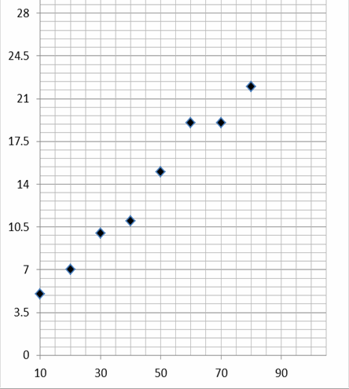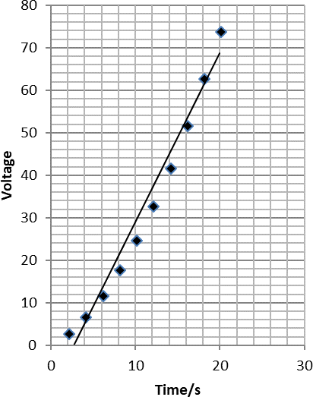

Graphs

After a practical activity the next step is to draw a graph that will be useful to you. Drawing a graph is a skill you should be familiar with already, but you need to be extremely vigilant at L3 and develop your skills. In fact skill development forms one of the Unit 2 Assessments. Before you draw your graph to need to identify a suitable scale to draw taking the following into consideration:

- the maximum and minimum values of each variable
- whether 0.0 should be included as a data point; graphs don’t need to show the origin, a false origin can be used if your data doesn’t start near zero.
- the plots should cover at least half of the grid supplied for the graph.
- the axes should use a sensible scale e.g. multiples of 1,2, 5 etc) Task: Identify how the following graphs could be improved
Graph 1 Graph 2

Unit 1C: Waves and communication

At GCSE you studied waves and in the Physics part of the L3 course you will explore this topic in more detail, so it is essential you have a good understanding of the content covered at GCSE. You can recap that using the following websites.

https://www.physicsclassroom.com/class/waves/Lesson-1/Waves-and-Wavelike-Motion

Seneca has a GCSE refresher unit of waves as part of its Physics: AQA A Level Preparation – summer 2020 course. Try this and
then move onto part 2 the A level taster section
https://app.senecalearning.com/classroom/course/eb1a286f-2cf3-486d-a591-5494d8b256c7

Here are some more links to review this topic and some tasks to try. http://www.bbc.co.uk/education/clips/zb7gkqt
https://www.khanacademy.org/science/physics/mechanical-waves-and-sound/mechanical- waves/v/introduction-to-waves

https://www.khanacademy.org/science/physics/mechanical-waves-and-sound/mechanical-
waves/v/introduction-to-waves

- Draw a diagram showing the refraction of a wave through a rectangular glass block. Explain why the ray of light takes this path.

- Describe the difference between longitudinal and transverse waves and give an example of each.

- Draw a wave and label the wavelength and amplitude.

Cells
The Biology in this L3 course will develop GCSE knowledge and build on this to help you understand the Unit 1:B Structure and function of cells and tissues topic. Complete the following tasks to keep up to date and so you are ready to start studying:
The cell is a unifying concept in biology, you will develop what you studied at GCSE in this L3 course. Prokaryotic and eukaryotic cells can be distinguished on the basis of their structure and ultrastructure. In complex multicellular organisms, cells are organised into tissues, tissues into organs and organs into systems.

Task: Read the information on these websites (make more Cornell notes if you wish):
http://www.s-cool.co.uk/a-level/biology/cells-and-organelles http://www.bbc.co.uk/education/guides/zvjycdm/revision

And take a look at these videos: https://www.youtube.com/watch?v=gcTuQpuJyD8 https://www.youtube.com/watch?v=L0k-enzoeOM https://www.youtube.com/watch?v=qCLmR9-YY7o

Task:
Produce a one page revision guide to share with your class in September summarising one of the following topics: Cells and Cell Ultrastructure or Prokaryotes and Eukaryotes.
Whichever topic you choose, your revision guide should include:
- Key words and definitions
- Clearly labelled diagrams
- Short explanations of key ideas or processes.

- Seneca has a GCSE refresher unit of 1.1.3 Cells, Tissues and organs as part of its Biology: AQA A Level Preparation – summer 2020 course. Try this
- https://app.senecalearning.com/classroom/course/76917ca0-ac10-43c9-8742-e49b861417b2
- and then move onto part 2 the A level taster section, part 2.1.4 ATP (see the following section)

Energy for Biological Processes – It would be really helpful to the course to understand what ATP is
In cellular respiration, glycolysis takes place in the cytoplasm and the remaining steps in the mitochondria. ATP synthesis is associated with the electron transfer chain in the membranes of mitochondria and chloroplasts in photosynthesis energy is transferred to ATP in the light- dependent stage and the ATP is utilised during synthesis in the light-independent stage.

Task: Read the information on these websites (you could make more Cornell notes if you wish): http://www.bbc.co.uk/education/guides/zcxrd2p/revision
http://www.s-cool.co.uk/a-level/biology/respiration

And take a look at these videos: https://www.youtube.com/watch?v=00jbG_cfGuQ https://www.youtube.com/watch?v=2f7YwCtHcgk

Task:
Produce an A3 annotated information poster that illustrates the process of cellular respiration and summarises the key points.
Your poster should include:
- Both text and images
- Be visually stimulating
- Key words and definitions
- Clearly labelled diagrams
- Short explanations of key ideas or processes.

The Chemistry in this L3 course will develop GCSE knowledge and build on this to help you understand Unit 1A: Periodicity and properties of elements:
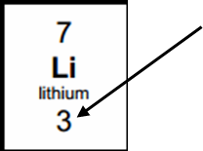
Seneca has a GCSE refresher unit of waves as part of its Chemistry: OCR A Level Preparation – summer 2020 course. Try this link to revise isotopes, moles and chromatography
https://app.senecalearning.com/classroom/course/9127b1a4-7e1e-4394-a184-ef26ed6d64c3

then move onto part 2 the A level taster section 2.2.2 electronic configuration
Chemistry Topic 1 – Electronic structure, how electrons are arranged around the nucleus
A periodic table can give you the proton / atomic number of an element, this also tells you how many electrons are in the atom.
You will have used the rule of electrons shell filling, where:
The first shell holds up to 2 electrons, the second up to 8, the third up to 8 and the fourth up to 18 (or you may have been told 8).
Atomic number =3, electrons = 3, arrangement 2 in the first shell and 1 in the second or Li = 2,1

At A level you will learn that the electron structure is more complex than this and can be used to explain a lot of the chemical properties of elements.
The ‘shells’ can be broken down into ‘orbitals’, which are given letters: ‘s’ orbitals, ‘p’ orbitals and ‘d’ orbitals.
You can read about orbitals here:
http://bit.ly/pixlchem1 http://www.chemguide.co.uk/atoms/properties/atomorbs.html#top

Now that you are familiar with s, p and d orbitals try these problems. Write your answer in the format: 1s2, 2s2, 2p6 etc.
Q1. Write out the electron configuration of:
a) Ca b) Al c) S d) Cl e) Ar f) Fe g) V h) Ni i) Cu j) Zn k) As Q2. Extension question, can you write out the electron arrangement of the following ions:
a) K+ b) O2- c) Zn2+ d) V5+ e) Co2+
Chemistry Topic 5 – Chemical equations
Balancing chemical equations is the stepping stone to using equations to calculate masses in chemistry. There are loads of websites that give ways of balancing equations and lots of exercises in balancing.
Some of the equations to balance may involve strange chemicals- don’t worry about that, the key idea is to get balancing
right.

http://bit.ly/pixlchem7 http://www.chemteam.info/Equations/Balance-Equation.html
This website has a download; it is safe to do so: http://bit.ly/pixlchem8
https://phet.colorado.edu/en/simulation/balancing-chemical-equations

Q5. Balance the following equations a. H2 + 02→ H20
b. S8+ 02→ S03
- HgO → Hg+ 02
- Zn+ HCl→ ZnCl2+ H2
- Na+ H20 → NaOH + H2
- C10H16+ CI2 → C + HCl
g. Fe+ 02→ Fe203
h. C6H1206+ 02→ C02+ H20 i. Fe203 + H2 → Fe + H20
j. Al + FeO → Al2O3 + Fe

Chemistry Topic 6 – Measuring chemicals – the mole
From this point on you need to be using an A level periodic table, not a GCSE one. You can view one here:

http://bit.ly/pixlpertab
https://secondaryscience4all.files.wordpress.com/2014/08/filestore_aqa_org_uk_subjects_aqa-2420-w-trb-ptds_pdf.png

Now that we have our chemical equations balanced, we need to be able to use them in order to work out masses of chemicals we need or we can produce.
The mole is the chemists equivalent of a dozen. Atoms are so small that we cannot count them out individually, we weigh out chemicals.
For example: magnesium + sulfur → magnesium sulfide
Mg + S → MgS
We can see that one atom of magnesium will react with one atom of sulfu. If we had to weigh out the atoms we need to know how heavy each atom is.
From the periodic table: Mg = 24.3 and S = 32.1
If I weigh out exactly 24.3g of magnesium this will be 1 mole of magnesium. If we counted how many atoms were present in this mass it would be a huge number (6.02 x 1023!!!!). If I weigh out 32.1g of sulfur then I would have 1 mole of sulfur atoms.
So 24.3g of Mg will react precisely with 32.1g of sulfur, and will make 56.4g of magnesium sulfide.
Here is a comprehensive page on measuring moles, there are a number of descriptions, videos and practice problems. You will find the first 6 tutorials of most use here, and problem sets 1 to 3.

http://bit.ly/pixlchem9 http://www.chemteam.info/Mole/Mole.html

If we weren’t on Lockdown and you were on holiday in the UK, or on a staycation at home, you could’ve explore one of these venues. Why not see if any of them have “virtual tours”.

Glasgow Science Centre - Glasgow

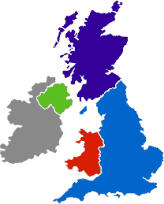Liverpool World
Museum - Liverpool

Spaceport - Wirral

Jodrell Bank Observatory - Cheshire
Kielder Observatory – Northumberland
and Life – Newcastle upon Tyne
MOSI – Museum of Science & Industry - Manchester
Alton Towers - Staffordshire

Electric Mountain - Snowdonia
Herschel Museum of Astronomy - Bath
@Bristol – Bristol
Bristol science centre The Royal Institute -
London
National Space Centre - Leicester
The Faraday Museum - London

Royal Observatory and Centre of the Cell -London

Do they have virtual tours: Why not explore?

Northern England and Scotland

  - Jodrell Bank Observatory – Cheshire – one of the largest moveable radio telescopes in the world and the
location of the filming of the BBC’s Stargazing Live. The site has both indoor and outdoor activities.
  - MOSI – Manchester – Massive free museum showing how science helped Britain lead the way through the industrial revolution. Contains hands on exhibits and displays and often host regular travelling exhibitions.
  - Liverpool World Museum / Spaceport – Liverpool/Wirral – Start the day off at an excellent family science museum with a top floor dedicated to astronomy including a planetarium. Take the ferry across the Mersey to another family friendly museum dedicated to spaceflight.
  - Kielder Observatory – Northumberland – Book ahead at this popular observatory in the midst of the darkest night skies the UK has to offer. Regular tours and opportunities to view the stars through professional telescopes take place on a nightly basis.
  - Glasgow Science Centre - The Centre is home to hundreds of interactive exhibits throughout the three engaging floors.

The Midlands and Wales

- Electric Mountain – Snowdonia – Set against a mountainous backdrop is a working pumped storage power station. Take a tour deep into the heart of the mountain and see the turbines spring into action to meet our ever increasing demand for electricity. Take a stroll up on of the UKs highest peaks in the afternoon.
- National Space Centre – Leicester - With six interactive galleries, the UK’s largest planetarium, unique 3D simulator experience, the award-winning National Space Centre in Leicester is an out of this world visitor attraction.
- Alton Towers – Staffordshire – Treat yourself to a go on a few rollercoasters whilst discussing Newton’s Laws. You may want to download and take these handy rollercoaster physics notes with you http://www.explainthatstuff.com/rollercoasters.html

Southern England

- Royal Observatory – London - Visit the Royal Observatory Greenwich to stand on the historic Prime Meridian of the World, see the home of Greenwich Mean Time (GMT), and explore your place in the universe at London’s only planetarium.
- Herschel Museum of Astronomy – Bath – As you walk around the picturesque Roman city – take an hour or two out at the home of one of the great scientists – discoverer of Infra-red radiation and Uranus.
- @Bristol – Bristol - home to the UK’s only 3D Planetarium and one of the biggest science centres.
- The Royal Institution – London – The birthplace of many important ideas of modern physics, including Michael Faraday’s lectures on electricity. Now home to the RI Christmas lectures and many exhibits of science history.
Nature reserves
- There are also hundreds of nature reserves (some of which are free) located all over the country including:
- RSPB sites at Lochwinnoch, Saltholme, Fairburn Ings, Old Moor, Conwy, Minsmere, Rainham Marshes, Pulborough Brooks, Radipole Lake, Newport Wetlands.
- Wildlife Trust Reserves and others at Rutland Water, Pensthorpe, Insh Marshes, Attenborough Centre, Inversnaid, Skomer, Loch Garten, Donna Nook, Chapmans Well, Woodwalton Fen, London Wetland Centre, Martin Down and Woolston Eyes Reserve.

Science on Social Media
Science communication is essential in the modern world and all the big scientific companies, researchers and institutions have their own social media accounts. Here are some of our top tips to keep up to date with developing news or interesting stories:

Find on Facebook:

National Geographic - since 1888, National Geographic has travelled the Earth, sharing its amazing stories in pictures and words.

Science News Magazine - Science covers important and emerging research in all fields of science.

BBC Science News - The latest BBC Science and Environment News: breaking news, analysis and debate on science and nature around the world.

Institute of Physics - The Institute of Physics is a leading scientific membership society working to advance physics for the benefit of all.

Nature - the profile page for nature.com for news, features, research and events from Nature Publishing Group

Science News Magazine - Science covers important and emerging research in all fields of science

Follow on Twitter:

Commander Chris Hadfield – former resident aboard the International Space Station @cmdrhadfield

Institute of Physics – The leading scientific membership society for physics @PhysicsNews

Scientific America – Journal sharing discoveries and insights into science that develops the world @sciam

SN Students – Science news for students @SNStudents

A level Biology – A hub for GCSE and A level biology students @flagellum_bio

A Level Biology – alevelbiology.co.uk provides resources for AQA, OCR and Edexcel A-Level Biology. @alevelbiologyuk

David Chalk –daily revision tips for AS and A2 Biology @teacherchalky1

Understand Biology – news stories relating to A level knowledge and understanding @a_level_biology

Sci Curious – feed from writer and Bethany Brookshire tweeting about good, bad and weird neuroscience
@scicurious

Daily A Level Chemistry Facts – Daily Chemistry Facts (Based on the A-Level AQA spec but most facts work with all)
@chemAlevels

Chemistry News –The latest chemistry news from only the best sources @chemistrynews

These Biology and physics websites all offer an amazing collection of resources that you should use again and again
throughout your course.
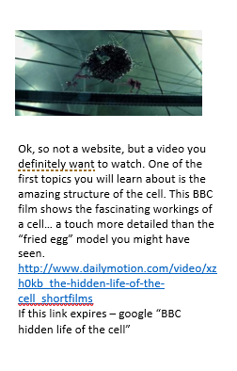

physics.org is brought to you by the Physics in Society team at the Institute of Physics.
Their aim is to inspire people of all ages about physics. Let them be your guide and show you the best physics places on the web. http://www.physics.org/abou tus.asp

A website written by James Irvine, a retired teacher from Sheffield. Although the website is primarily written to support AQA, the material is also easily transferable to other exam boards. http://www.antonine-education.co.uk/

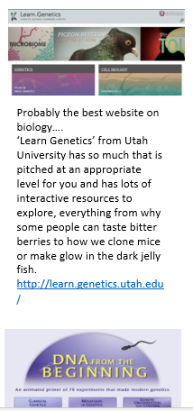

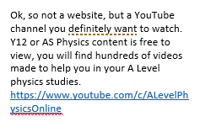

These Chemistry websites all offer an amazing collection of resources that you should use again and again throughout your course.

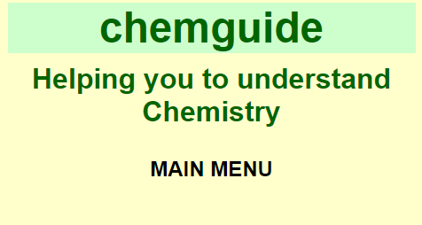
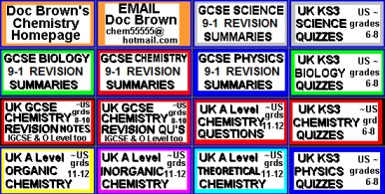
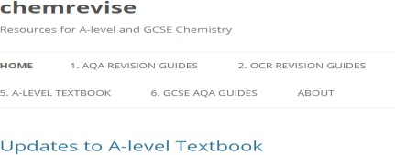

This website is very detailed and identifies other resources which are sharing incorrect or outdated information and suggests the correct materials to use. The site also contains links to the syllabuses of many exam boards which means it is accessible and useful to all students. https://www.chemguide.co.u k/

The free revision website for students studying GCSE and A- levels. S-cool provides revision guides, question banks, revision timetable and more https://www.s-cool.co.uk/a- level/chemistry

Doc Brown is a website dedicated to all three science subjects; physics, chemistry and biology. It provides the user with summarised notes (useful for making flash cards) and practice questions to further their knowledge and understanding.
The site provides resources from a wide range of exam boards including AQA, Edexcel, Chemistry, CCEA, OCR, WJEC, CIE and Salters from GCSE level to A2. http://www.docbrown.info/

The site was first made to host revision guides that are written for AQA A-level Chemistry. These revision guides have already been circulating on the internet for a couple of years on places like student room. This will be the place for the most up to date versions of them. The site has now extended to cover other exam boards. (OCR and Edexcel) https://chemrevise.org/

Tons of awesome courses in one awesome channel! Check out the playlists for past courses in physics, philosophy, games, economics, U.S. government and politics, astronomy, anatomy & physiology, world history, biology, literature, ecology, chemistry, psychology, and of course, chemistry! https://www.youtube.com/user/crash course/featured

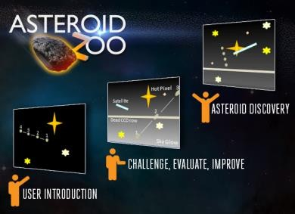
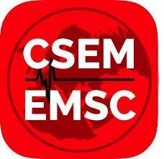
Want to stand above the rest when it comes to UCAS? Now is the time to act.
MOOCs are online courses run by nearly all universities. They are short FREE courses that you take part in. They are usually quite specialist, but aimed at the public, not the genius!
There are lots of websites that help you find a course, such as edX and Future learn.
You can take part in any course, but there are usually start and finish dates. They mostly involve taking part in web chats, watching videos and interactives.

© Copyright The PiXL Club Ltd, 2018
Day 4 of the holidays and boredom has set in?
There are loads of citizen science projects you can take part in either from the comfort of your bedroom, out and about, or when on holiday. Wikipedia does a comprehensive list of all the current projects taking place. Google ‘citizen science project’

Completing a MOOC will look great on your Personal statement and they are dead easy to take part in!

L3 Chemistry baseline assessment
The following quick test is designed to test your recall, analysis and evaluative skills and knowledge.
Remember to use your exam technique: look at the command words and the number of marks each question is worth. A suggested mark scheme is provided for you to check your answers.

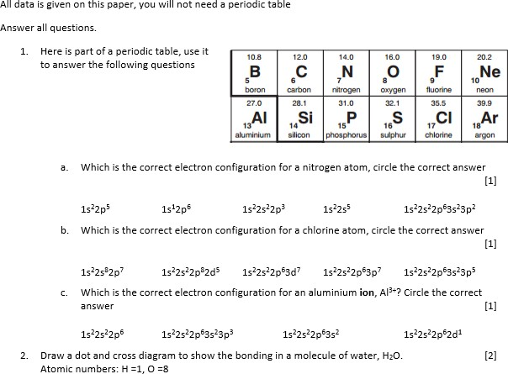

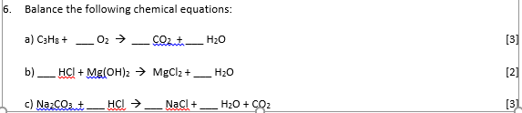
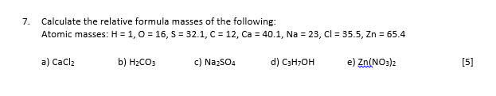

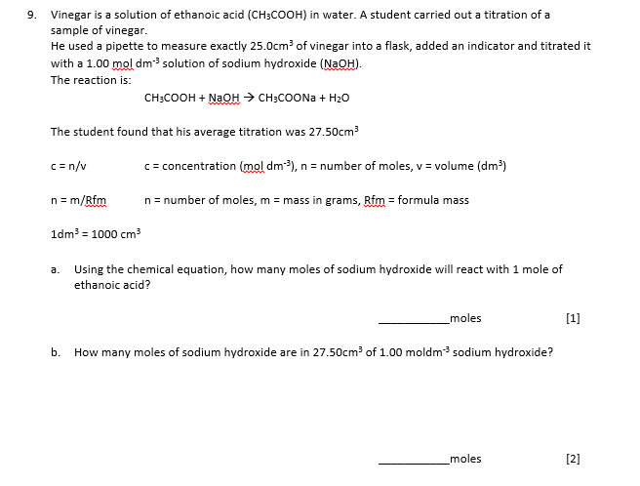

L3 Physics baseline assessment

The following 20 minute test is designed to test your recall, analysis and evaluative skills and knowledge.
Remember to use your exam technique: look at the command words and the number of marks each question is worth. A suggested mark scheme is provided for you to check your answers.

A single piece of graph paper is required for the completion of the assessment. You may use a calculator.

Question  Number | Topic | Score
1 | Symbols and Prefixes | /3
2 | Standard Form | /4
3 | Re-arranging Equations | /3
4 | Atomic Structure | /3
5 | Recording Data | /3
6 | Graphing | /4
 |  | Total /20

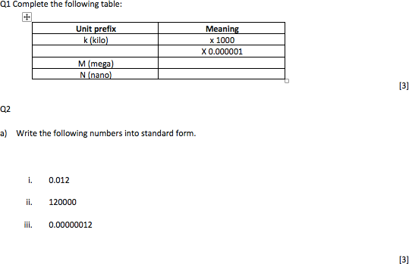

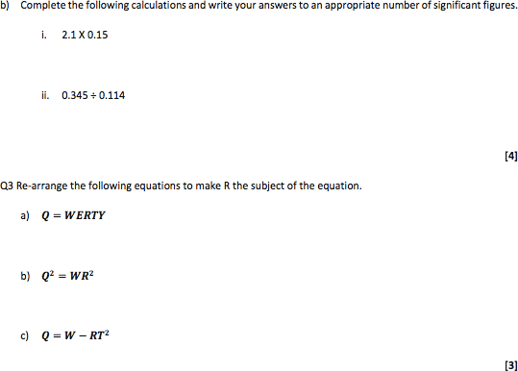

Q4

  - Name the 3 particles (from GCSE) that make up an atom.

  - Which one of the above particles is not found in the nucleus of an atom?

  - Which of the above particles will be found in varying quantities in the nuclei of isotopes of the same element?

Q5

- Complete the following table

Voltage ( ) | (A)
 | Repeat 1 | Repeat 2 | Average
2 | 0.23 | 0.26 | 0.25
4 | 0.46 | 0.53
6 | 0.69 | 0.78 | 0.74
8 | 0.92 | 1.04 | 0.98
10 | 1.15 | 1.30 | 1.23

[3]

Q6

  - Use your piece of graph paper to plot a graph of Current (x-axis) against Voltage (y-axis) drawing a line of best fit through your data points.

[4]

  - Find the gradient of your line of best fit

[3]

Level 3 Physics Baseline Assessment SUGGESTED MARKSCHEME
Q1

a)

Unit prefix | Meaning
k (kilo) | x 1000
μ(micro) | X 0.000001
M (mega) | x 1000000
N (nano) | x 0.000000001
[3]

Q2

- Write the following numbers into standard form i. 0.012 𝟏. 𝟐 × 𝟏𝟎^{−𝟐}
ii. 120000 𝟏. 𝟐 × 𝟏𝟎^{𝟓}
iii. 0.00000012 𝟏. 𝟐 × 𝟏𝟎^{−𝟕}

[3]
- Complete the following calculations and right your answers to an appropriate number of significant figures. i. 2.1 X 0.15
a. 0.315 = 0.32(2sf)
ii. 0.345 ÷ 0.114
a. 3.0263…=3.03 (3sf)

Award 1 mark for correct answer and 1 mark for correct number of s.f. [4] Q3 Re-arrange the following equations to make R the subject of the equation.
a) 𝑸 = 𝑾𝑬𝑹𝑻𝒀

𝑹 =
𝑸

𝑾𝑬𝑻𝒀

b) 𝑸^{𝟐} = 𝑾𝑹^{𝟐}

𝑹 =
𝑸𝟐

𝑾

c) 𝑸 = 𝑾 − 𝑹𝑻^{𝟐}

𝑹 =
𝑾 − 𝑸

𝑻𝟐

[3]

Q4

  - Name the 3 particles (from GCSE) that make up an atom

Proton, Neutron, Electron (any order) [1]

  - Which one of the above particles is not found in the nucleus of an atom?

Electron [1]

  - Which of the above particles will be found in varying quantities in the nuclei of isotopes of the same element?

Neutron [1]

Q5

a)

Voltage (V) | Current (A)
 | Repeat 1 | Repeat 2 | Average
2 | 0.23 | 0.26 | 0.25
4 | 0.46 | 0.53 | 0.50
6 | 0.69 | 0.78 | 0.74
8 | 0.92 | 1.04 | 0.98
10 | 1.15 | 1.30 | 1.23

1 Mark for correct unit (V or volts)

1 Mark for correct heading (Current in Amps or A)

1 Mark for correct average, 1 Mark if rounded to correct number of s.f.

[3]

Q6

- Use your piece of graph paper to plot a graph of Current (x-axis) against Voltage (y-axis) drawing a line of best fit through your data points.

1 mark if BOTH x and y axis cover half the graph paper 1 mark for correctly labelling x and y axis including units 1 mark if data points are correctly plotted (check 3)
1 mark for correct line of best fit (with even spread of points above and below)

[4]

© Copyright The PiXL Club Ltd, 2018

- Find the gradient of your line of best fit

Working must be shown for the award of any marks 1 mark for correct y axis read offs
1 mark for correct x axis read offs

1 mark for correct calculation of their own gradient

[3]

L3 Biology baseline assessment

The following quick test is designed to test your recall, analysis and evaluative skills and knowledge.
Remember to use your exam technique: look at the command words and the number of marks each question is worth. A suggested mark scheme is provided for you to check your answers.

  - Every living organism is made of cells.

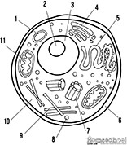

Image taken from http://prestigebux.com/worksheet/label-an-animal-cell-worksheet

- Label the following parts of the animal cell:

2 ……………………………………………………………………………………………………………………………………………………………

5 ……..……………………………………………………………………………………………………………………………………………………

8 …………………………………………………………………………………………………………………………………………………………..
(3)
- Describe how the structure of the cell membrane is related to its function?

…………………………………………………………………………………………………………………………………………………………………

…………………………………………………………………………………………………………………………………………………………………

…………………………………………………………………………………………………………………………………………………………………
(3)

  - Scientists need to be able to interpret data in graphs to decide if there are trends in the results. For each graph below, describe the trend.
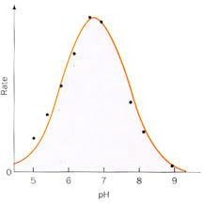
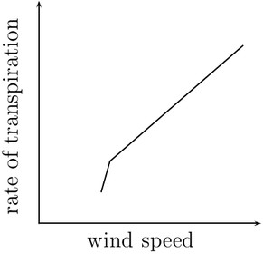
…………………………………………………………… ……………………………………………………………
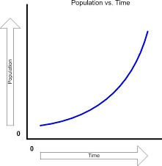
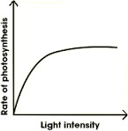

…………………………………………………………… ……………………………………………………………(4)

Biology baseline assessment Suggested Mark Scheme:

Question |  |  | Answer | Marks
1 | A |  | 2 Nucleolus  5 Smooth Endoplasmic Reticulum 8 Golgi body | 1  1  1
4 | b |  | Any 3 from the following structure and function must be given.  Lipid bilayer - has a hydrophobic inside and hydrophilic outside,  allowing for selective permeability  Proteins - allow for specific substances to come or some molecules to  pass through  Cholesterol - allows for fluidity of the membrane  Glycoproteins - for cell identification they serve as markers | 1  1  1  1

Question |  |  | Answer | Marks
2 |  |  | Top left: transpiration increases when wind speed increases/there is a | 1
 |  |  | positive correlation
 |  |  | Top right: rate increases with pH until the optimum is reached, after | 1
 |  |  | the optimum, rate decreases
 |  |  | Bottom left: Increasing light initially increases the rate of | 1
 |  |  | photosynthesis, but after a while remains constant
 |  |  | Bottom right: Population increases slowly at first and then increases at | 1
 |  |  | a greater rate/increases exponentially

© The PiXL Club Ltd. June 2018
This resource is strictly for the use of member schools for as long as they remain members of The PiXL Club. It may not be copied, sold, or transferred to a third party or used by the school after membership ceases. Until such time it may be freely used within the member school.

All opinions and contributions are those of the authors. The contents of this resource are not connected with, or endorsed by, any other company, organisation or institution.

PiXL Club Ltd endeavour to trace and contact copyright owners. If there are any inadvertent omissions or errors in the acknowledgements or usage, this is unintended and PiXL will remedy these on written notification.

