Transition Materials for A Level History
The Tudors:
England, 1485 - 1603

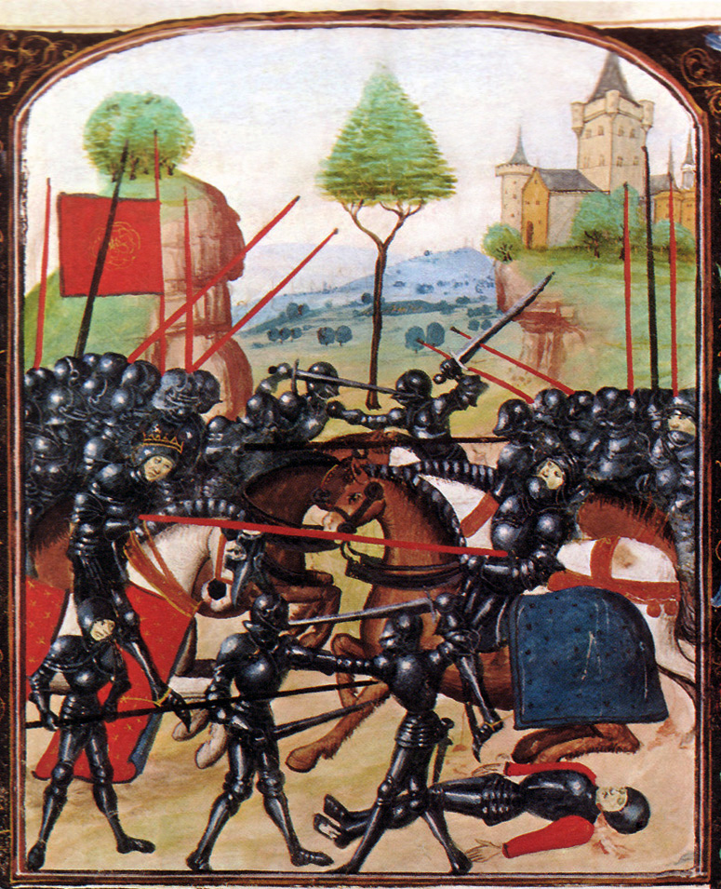
Introduction
It is great that you are considering studying History at A Level.
This pack contains a programme of activities and resources to prepare you to start an A Level in History in September. It is aimed to be used after you complete your GCSE throughout the remainder of the summer term and over the summer holidays to ensure you are ready to start your course in September.
Discovering the past is great fun. I hope that you will agree!

Contents

- Reading List
- Independent Research
- Required Knowledge and Skills
- Baseline Assessment
- The world is out there ….

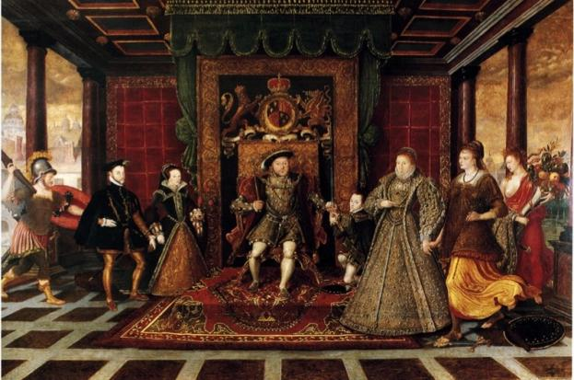

- Reading List

Fiction | - The White Queen, Phillippa Gregory  - The Red Queen, Phillippa Gregory  - The Kingmaker’s Daughter, Phillippa Gregory  - The Sunne in Splendour, Sharon Kay Penman  - Richard III, William Shakespeare
Non-Fiction | - The Plantagenets, Dan Jones (2013)  - The Hollow Crown: The Wars of the Roses and the Rise of the Tudors, Dan Jones (2015)  - The Wars of the Roses, Michael Hicks (2012)  - The Family of Richard III, Michael Hicks (2015)  - Winter King: The Dawn of Tudor England, Thomas Penn (2012)
Film Resources | The White Queen  The Hollow Crown  Richard III (1995)  The Other Boleyn Girl (2003)  Wolf Hall (2015)

- Independent Research

- Research 5 battles of the Wars of the Roses. Create fact files with as much detail as possible. Think: What, When, Where, Why, Consequences. Feel free to add extra information that you find interesting.
- Watch the film version of Shakespeare’s Richard III. What can we learn from this play about Richard III and the England he ruled over?
- After watching the above film, research the historical context. When was the play written and why? How does this information affect the reliability of this play as a source?
- Create an A3 information sheet, with facts and images, of the following British monarchs: Richard III, Henry VII, Henry VIII, Edward VI, Mary I and Elizabeth I.
- Find at least 5 images that show what life was like in Tudor England. Annotate each to tell its story.

Suggested websites:
- http://www.historylearningsite.co.uk/medieval-england/
- http://www.warsoftheroses.com/
- http://www.britannica.com/event/Wars-of-the-Roses
- http://www.richardiii.net/9_1_wotr.php
- http://www.historyextra.com/article/military-history/12-facts-wars-roses
- http://shakespeare.mit.edu/richardiii/full.html
- http://www.sparknotes.com/shakespeare/richardiii/
- https://www.youtube.com/watch?v=ZH7CKzhCyyA
- http://tudorhistory.org/monarchs/
- http://www.royal.gov.uk/HistoryoftheMonarchy/KingsandQueensofEngland/TheTudors/TheTudors.aspx
- http://www.historyonthenet.com/tudors/monarchs.htm
- http://tudorhistory.org/
- http://tudortimes.co.uk/

- Required Knowledge and Skills

- Draw a timeline explaining the Wars of the Roses.
- What was the role of a medieval king? How does this differ when compared with the role of the British monarch today?
- What was life like in medieval England? Create A3 fact files for each aspect, such as landscape, economy, education, religion and food. Feel free to add extra fact files following your research.
- What role did religion play in Tudor England? What was the religious landscape of Europe in the C16th? Tip: Download and annotate a map of Europe.
- Draw a family tree of the Tudors. Add images.
- What is a Usurper? What was Henry VII’s claim to the throne?
- Research the Princes in the Tower. What do you think happened to them? What motive would Richard III have had for murdering the boys?
- Outline the key events of the Battle of Bosworth.
- Why was Elizabeth of York’s marriage to Henry Tudor important?
- Complete the glossary of key terms on the next page.

Glossary:
Armiger
Attainder
Borough
Constable
Demesne
Freehold
Glebe
Noble
Reeve
Sheriff
Tithe
Tourney
Villein
Wardship
Feudal System
Act of Succession
Almoner
Closet
Codpiece
Dispensation
Jousting
Oratory
Papal Bull
Privy Chamber
Reformation
Sumptuary Laws
Sweating sickness

- Baseline Assessment

‘Henry VII deserved to become King of England in 1485’. Explain why you agree or disagree with this view.

Answer the above essay question.
You should aim to write at least 3 sides of A4.
Your teacher will be looking for the following:
- A balanced answer
- Arguments supported by precise historical knowledge
- Well-structured paragraphs
- A clear judgement that is sustained throughout your essay

- The World is Out There …..

- Visit a Tudor building in your local area. Some examples include Hampton Court, Thornbury Castle, Penshurst Place, Montacute House, The Vyne, Hever Castle, Little Moreton Hall, Eltham Palace.
- Visit the Tower of London and spend time in the White Tower.
- Visit the Tudor galleries in the National Portrait Museum. Research 5 individuals who caught your attention!
- Read Shakespeare’s plays Richard III and Henry VIII. Even better if you can see an adaptation on stage.
- Visit The Globe Theatre, London.
- Watch the TV series The White Queen.
- Watch the TV series Hollow Crown.
- Visit a local museum to learn what life was like in your area during the reign of Tudor monarchs.

AQA Unit 1C The Tudors: England, 1485 - 1603
However, this booklet could also be used to introduce
- AQA Unit 2B The Wars of the Roses, 1450–1499
- Edexcel Paper 1, Option 1B: England, 1509–1603: authority, nation and religion
- Edexcel Paper 3, Option 30: Lancastrians, Yorkists and Henry VII, 1399–1509
- Edexcel Paper 3, Option 31: Rebellion and disorder under the Tudors, 1485–1603
- OCR Unit Y105 – England 1445–1509: Lancastrians, Yorkists and Henry VII (Enquiry topic: Wars of the Roses 1445–1461)
- OCR Unit Y106 – England 1485–1558: The Early Tudors (Enquiry topic: Mid Tudor Crises 1547–1558)
- OCR Unit Y107 – England 1547–1603: The Later Tudors (Enquiry topic: Mid Tudor Crises 1547–1558)
- OCR Unit Y306 – Rebellion and Disorder under the Tudors 1485–1603
- OCR Unit Y307 – Tudor Foreign Policy 1485–1603

