Transition materials - Design and Technology

As a prospective student of Design and Technology, you should already be taking a real and active interest in this subject. This progression booklet will help build your knowledge and skills in Design and Technology and get you off to the best possible start this September. The tasks set for you will give you a taste of what is involved and get you thinking like a designer.
The most useful books you will need to obtain for the course are:
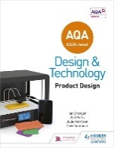AQA AS/A-Level Design and Technology: Product Design (ISBN: 9781510414082)

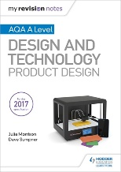My Revision Notes: AQA A Level Design and Technology: Product Design (ISBN: 9781510432291)

Contents:
Task Page No.
Material research 2
Manufacturing processes 2
CAD/CAM 3
Design theory 3
Further research 3

To help you develop your skills, knowledge and understanding in the following areas:
- Technical principles
- Designing and making principles
Complete the following tasks:

Technical principles

Materials
Understanding materials and their characteristics and working properties are crucial in design.
Task: Research the following materials and create a mind map based on your research and understanding of their characteristics and working properties:
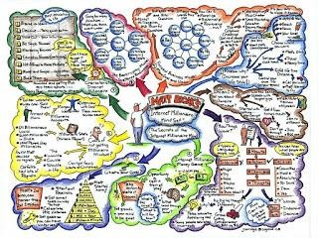
- Woods
- Metals
- Polymers
- Textiles
- Composites
- Smart and modern materials
- Papers and card

Production processes
Task: Research the following manufacturing processes and create a presentation explaining the process. Include diagrams/sketches to aid your understanding.
- Injection Moulding
- Extrusion
- Laminating
- Milling
- Turning
- Casting

Designing and Making Principles

CAD/CAM
Read the article at the link below.
https://www.inc.com/encyclopedia/computer-aided-design-cad-andcomputer-aided-cam.html
While many students have already downloaded and used this in GCSE, if not please register and download Autodesk fusion (https://www.autodesk.co.uk/products/fusion-360/students-teachers-educators) Ensure you use your school email and include relevant dates and courses.
Task: Once you have done this Warwick university has a great series of tutorials for you to complete. (Please be aware Autodesk Fusion is regularly updated so icons and pulldowns can change slightly)
https://warwick.ac.uk/fac/sci/wmg/about/outreach/resources/fusion_tutorials/
Keep a record of the completed tasks as screenshots and create a mini-presentation of your CAD which you can show us in September.
If you complete this and feel inspired, why not create a CAD rendered/ animated version of your Y11 project.

Design Theory

Task: Research a design movement and redesign an everyday object using the influence of the movement. Evidence the sketches in your sketchbook. Include a photograph of the product and then begin rapid sketching your initial ideas. Evaluate and analyse your ideas and develop them further. Annotate your development, explaining your design ideas. Draw a final design and explain how the design has been influenced.

http://www.vam.ac.uk/page/0-9/20th-century-design-styles/

Further Research

This list gives suggestions for further research.

www.designmuseum.org/design www.vam.ac.uk www.sciencemuseum.org.uk https://www.designcouncil.org.uk/

