Transition materials for A Level History

Russia 1855 - 1964

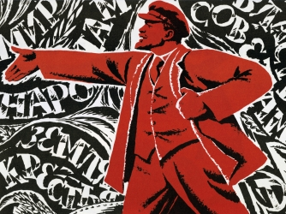

Introduction

So you are considering studying History at A level…

Welcome to the A level History pack preparing you to start your A level History course

This pack contains a step by step programme of activities and resources created to prepare you for the academic demands of A level History study.

All activities are aimed to be used after you complete your GCSE exams and should be completed in stages throughout the remainder of the summer term and over the summer holidays to ensure you are ready to start your course in September.

Contents

Topic | Page number
Introduction | 1
Contents | 2
Reading list | 3
Independent research | 6
Required knowledge and skills | 8
Baseline assessment | 11
The World is out there… | 12
Specification information | 13

Reading List

Books – Non Fiction

- Russian History: A very short introduction: Geoffrey Hosking – This book discusses all aspects of Russian history, from the struggle by the state to control society to the transformation of the nation into a multi-ethnic empire, Russia's relations with the West, and the post-Soviet era.

- Stalin: A Biography: Robert Service – A full assessment of Stalin from his early years in Georgia, his youthful activism, his relationship with Lenin, his family and his party members.

- The Russian Revolution: A Very Short Introduction – S.A Smith – This focusses on the main events and developments in Soviet Russia between 1917 – 1936.

Books – Fiction

- The Road of Bones: Fine, Anne - Based on life in Russia under Stalin, it is a fable about the nature of totalitarianism. It reveals how power corrupts and how quickly the oppressed can become the oppressors.

- Natasha’s Will: Joan Lingard - A dangerous journey into exile during the Russian Revolution. When Natasha’s grandfather is arrested in St Petersburg in 1917, her aristocratic family are forced to flee for their lives.

- Animal Farm: A Fairy Story: George Orwell – A well- known classic story detailing the events leading up to the Russian Revolution of 1917.

Films

- The Romanovs – An Imperial Family – A Russian film with subtitles, set in 1917 focussing on the last days of Tsar Nicholas II and the rest of the Romanov family.

- Enemy at the Gates – Set in 1942, in the Battle of Stalingrad, the main character, Vasily Zaytsev (played by Jude Law), becomes the poster boy for the Red Army due to his sniper skills.

- Animal Farm – The cartoon version of the book, showing the events leading up to the Russian Revolution.

- Child 44 – Featuring Tom Hardy, the film follows a disgraced member of the Russian military police. Charged with investigating a series of child murders during the Stalin era, where supposedly this sort of crime doesn’t exist.

- Bridge of Spies – Featuring Tom Hanks, an American lawyer is recruited to defend an arrested Soviet spy in court, and organise an exchange of the spy for a captured American pilot.

- Goodbye Lenin – Although not set within the time parameter of the topic, this comedy focusses on a young man who has to protect his fragile Mother who has come out of a long coma from a fatal shock that Communism has ended.

Useful links

- http://www.bbc.co.uk/education/topics/zq7qtfr/resources/1

- http://www.bbc.co.uk/schools/gcsebitesize/history/mwh/russia/

Independent Research

1855-1905 – Alexander II, Alexander III, Nicholas II
Task: Create a one page fact file on each Tsar.
Each should include: Name, reign, family background, events during his reign, impact, end of reign, death.

1905-1917 – The downfall of the Romanovs
Task: Watch the documentary below. The first half should give you the background for the above section. For the second half, create a mind map using the following headings:
Impact of World War One
1905 Revolution
The downfall of the Romanovs/causes of the 1917 revolution
Rasputin

Strengths of the Bolsheviks

https://www.youtube.com/watch?v=BpHD5ts2u-o&safe=active

1917-1924 – The Bolshevik early years
Task: Consider the questions below:
- Why was Lenin so popular in 1917?
- Name 3 events that happened between 1917 and 1924.
- Did Lenin remain popular?

1924-1934 – Stalin comes to power
Task: Create a fact file on Josef Stalin.
Include: Early life, political beliefs before 1917, role in 1917 revolution, role in Bolshevik party.

1934-1953 – The Terror!
Task:
- Look up the role of the NKVD in Russia under Stalin
- Investigate the interrogation techniques used by the NKVD
- What do you think it was like to live under Stalin?

1953-1964 – Khrushchev and the Cold War
Task:
- Read the following article – why do you think this speech had such a big impact?
- Look up the definition of foreign policy. What do you think the cartoonist’s opinion was, about foreign policy of the USSR and the USA?
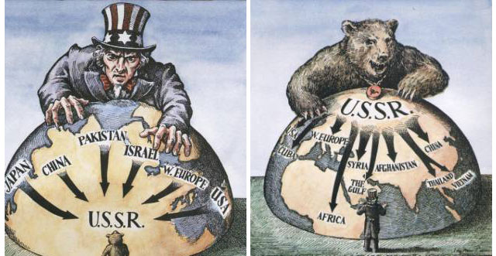
Required Knowledge and Skills
Key Pre Knowledge topics
- Fact File of Russia – Research the situation in modern day Russia including the following facts:
- Population
- Capital
- Flag
- Currency
- Border countries
- Border continents
- President
- Land area
- Ethnic make-up
- Religions
- Languages

- Russian Map work – Print off a colour A4 map of Russia. Locate and mark the following:
- St Petersburg
- Moscow
- Novgorod
- Arctic Ocean
- Siberian Plane and Peninsula
- Ural Mountains

- Glossary of key terms – Create a glossary of the following words:

- Tsar
- Liberalism
- Revolution
- Intelligentsia
- Serf
- Serfdom
- Zemstva
- Emancipation
- Taxation
- Autocracy
- Slav
- Communism
- Capitalism
- Assassination
- Bolshevik
- Menshevik
- Cheka
- Soviets
- New Economic Policy
- Politburo
- Proletariat
- Bourgeoisie
- Collectivisation
- Gulag
- Totalitarian

- Timeline – Create a timeline of key events of 1905 – 1917. Your first event should be Bloody Sunday and your last event should be the October Revolution.

- Job Description – What does it take to be a Tsar? Create a job description for someone who would like to rule a country as great as Russia. What key qualities would the candidate need to have?

- Romanov Family Tree – Dating back to Alexander I, create a family tree of the ruling Romanov dynasty.

- Quiz work – Create a ten question quiz from all your knowledge from this section of study that you can give to your classmates. Don’t make this quiz easy for them!

Baseline Assessment

Task 1 – Historian’s opinion
'The emancipation had to be, he knew it, but he did not like it' Crankshaw, 2000
Write a paragraph on what this historian’s opinion might be on the reforms that Nicholas brought in.

Task 2 – Essay writing
You will need to complete two essays based on the research you have done. The questions and suggested structure are below:

- “Tsar Nicholas II was an effective leader”. How far do you agree with this statement?
- “Stalin was a ruthless dictator” How far do you agree with this statement?
Suggested structure:
Four paragraphs (two arguing each side), and a conclusion.

The World is out there…

- Pushkin House – Visit Pushkin House in central London as it is the Russian culture centre in London. http://www.pushkinhouse.org/

- London Walks – Visit this website to find a variety of monuments/buildings and shops - http://london-walks.rbth.com/

- Highgate cemetery – Visit Highgate cemetery in Highgate, North London to visit the figurehead of Communism, Karl Marx’s grave.

- The Society for Co-operation in Russian and Soviet Studies – This library and cultural centre promotes knowledge of the culture, language and history of Russia and the former Soviet Union. The SCRSS is based in London and has a list of current activities on its’ website - http://www.scrss.org.uk/

- The Kompass – This website is “your pass to all things Russian in the U.K” - http://thekompass.rbth.co.uk/

- Royal Air Force Museum – Visit the National Cold War exhibition in Shropshire for a comprehensive study of Cold War artefacts. http://www.rafmuseum.org.uk/cosford/things-to-see-and-do/hangars/cold-war.aspx

- Theatre – Animal Farm – This is regularly performed in and around London.

Specifications that offer this course

- AQA – Tsarist and Communist Russia – 1865 – 1964
- OCR – From Autocracy to Communism: Russia 1894 – 1941
- Edexcel – Russia in Revolution 1894 – 1924
- Edexcel – The Making of Modern Russia – 1855 - 1991

Created by Francesca Malone and Natalie Slade

