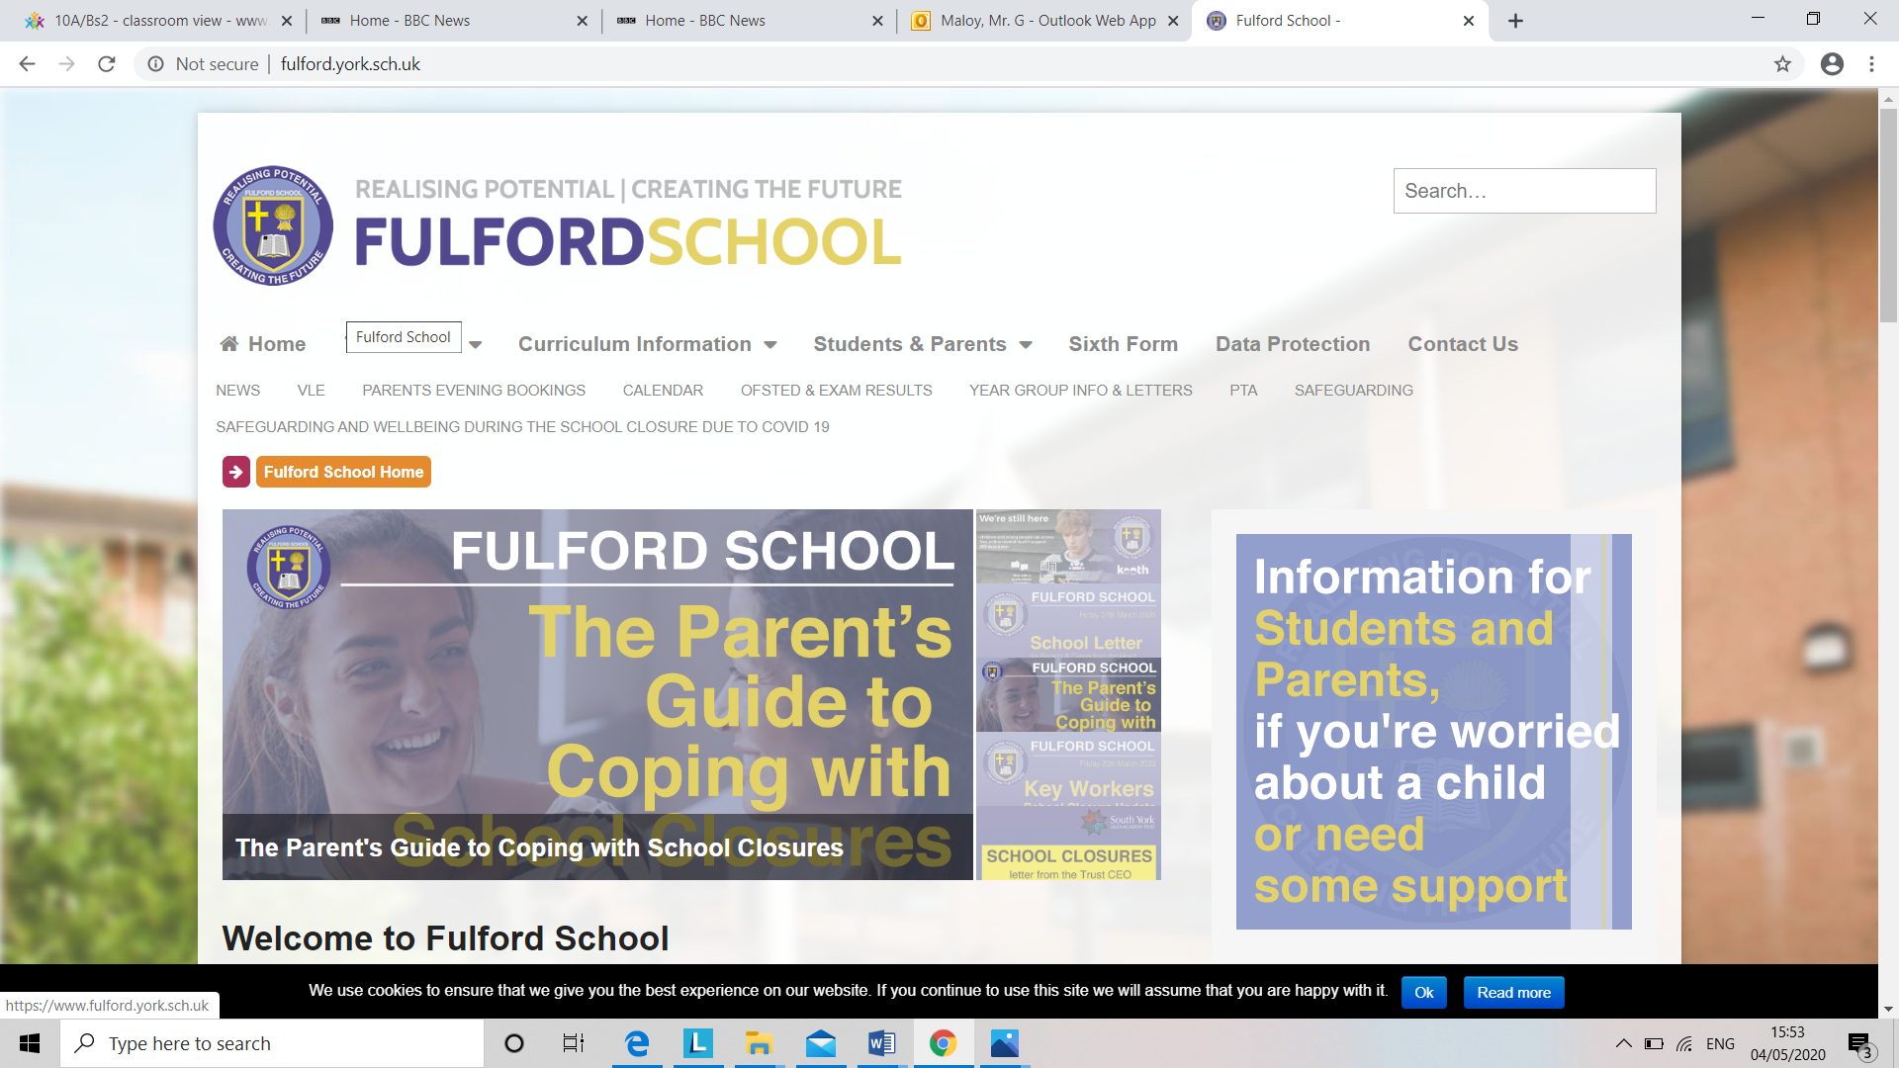**­­**

**A Level Business Transition Booklet**

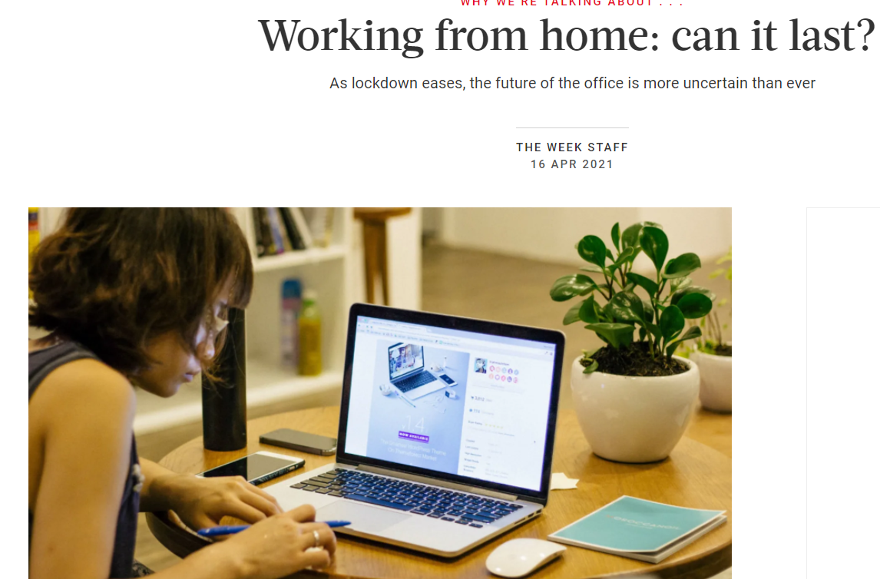

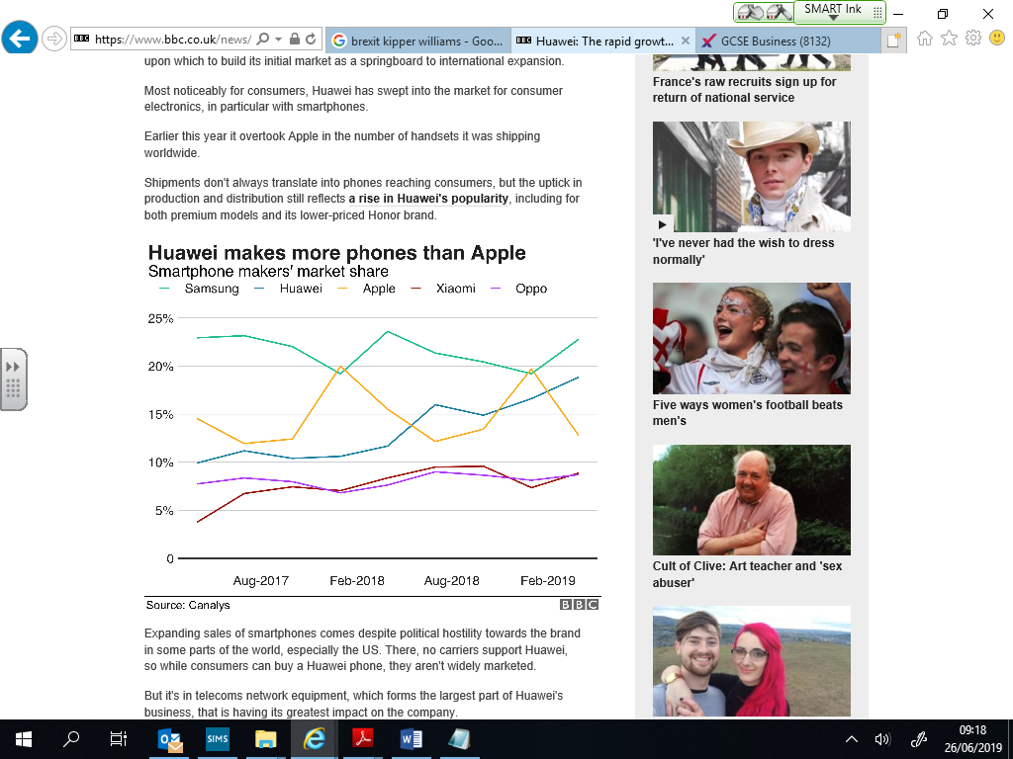

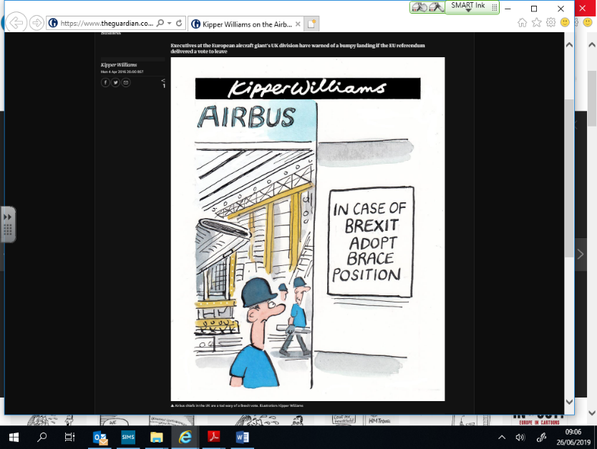

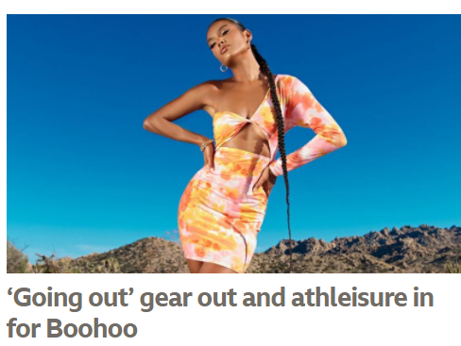

**Welcome**

Congratulations and well done on successfully transitioning to the A Level Business course! The purpose of all A Level courses is to allow you to pursue subjects that really interest you and are designed to facilitate progression into higher education and a career in the world of work. A Level Business, in particular, will give you a really strong grounding in how business organisations of varying size and status operate and so should give you an appreciation of the qualities required to successfully work in business organisations or even run your own one in years to come. So welcome to a dynamic, ever evolving and very useful subject!

**The basics**

Business is all around you every day, it isn’t hard to see how it has affected you and will affect your future. Take Brexit for example, do you view that as a positive or a negative for the UK and more importantly, for yourself? How will UK businesses adapt to the new trading relationships we now have with former EU partners? Will new market opportunities in Asia, for example, allow businesses to grow and prosper in a new trading world? Ethics in business is also now a major determinant of business success. Many businesses are now realising that there is not only money to be made by developing an ethical stance but that it makes sense from a moral perspective, to be more sustainable in their practices. Then of course, there are economic factors that are influencing businesses, such as inflation. What will be the impact on UK businesses because of rising levels of inflation? How will UK businesses react to increased costs of materials and labour in the future? Will they be able to source cheaper employees and raw material in future or are we heading for a periods of permanently increased inflation over the next few years?

**The expectations**

Business is a subject that continues to change, it is a forward looking subject. It is a subject that requires writing in context. You cannot rely only on a textbook alone. To be successful you will need to show:

1. *Awareness of business in the real world via media news sources*
2. *An ability to conduct independent research*
3. *Show logical chains of argument. Don't jump steps, link them in your answers*

**Task 1: Download and print off the course specification – the pages you need are pages 10-31. Set up a Business folder and put the print out at the front of your folder for future reference. Have a quick look at the topics you will be covering in the next 2 years.** [**https://filestore.aqa.org.uk/resources/business/specifications/AQA-7131-7132-SP-2015.PDF**](https://filestore.aqa.org.uk/resources/business/specifications/AQA-7131-7132-SP-2015.PDF)

**The companies you really should know!**

It is impossible to know which companies will be examined in your assessments. However, it is imperative that you keep up to date with issues and developments that affect many organisations. Become familiar with these companies, they will help you contextualise your answers.

**Task 2: Investigate 2 of the companies overleaf. Choose organisations that really interest you and select contrasting organisations – eg a UK and a US business; a business from 1 industry such as sports/leisure and another from another such as food manufacturing or gaming, for example. For each organisation, find out:**

* **The main products and services it sells**
* **The type of business ownership of the organisation – eg is it a limited company? If so what type? In the US, a company may be known as incorporated or Inc. equivalent to a plc here**
* **The leader/ CEO of the company and their values**
* **How successful the business has been over recent years and why – try and find some data such as share price, sales and profit levels to illustrate your answer**

**PRODUCE A 2 SIDED REPORT SUMMARISING THE 2 BUSINESSES AND THE DIFFERENCES BETWEEN THEM. USE THE SUBHEADINGS ABOVE TO STRUCTURE YOUR REPORT**

**IKEA**

**Vodafone**

**Shell**

HSBC

**Nike**

**Apple**

**facebook**

**Nestle**

**TOYOTA**

BRITISH AIRWAYS

**TESLA**

***Virgin***

**Unilever**

**Cadbury**

TESCO****

***Mars***

**Rolls**

**Royce**

*BARCLAYS*

Google

**Volkswagen**

**Amazon**

**Coca-Cola**

**STARBUCKS**

John Lewis

**Keep yourself up to date and informed**

One of the best ways to spend time between now and the start of the A Level Business course is by upgrading your real life business knowledge. Start now by using a wide range of sources such as the ones below to gain a real life understanding of real life business.

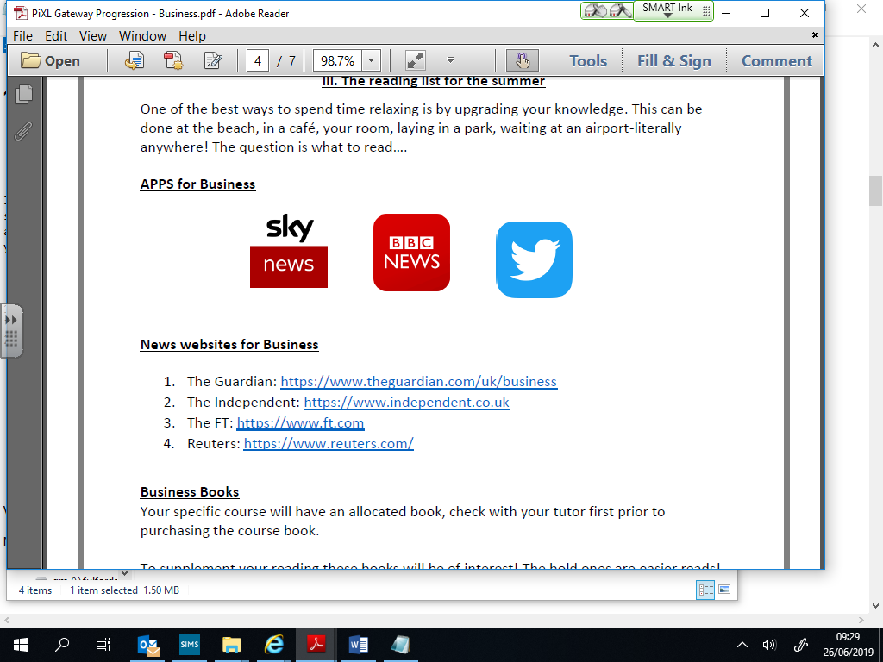

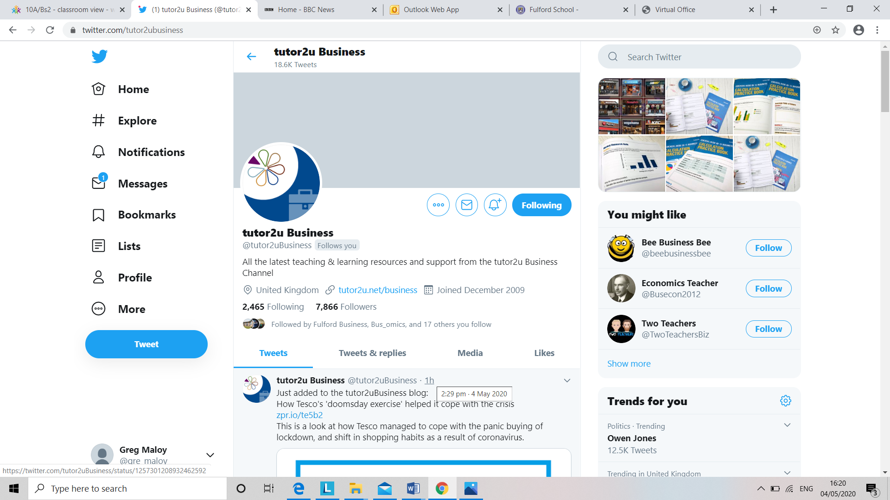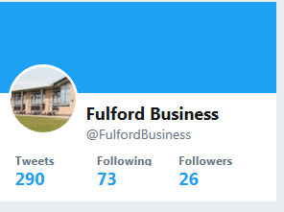

This is not a fully comprehensive list but following **Tutor2u Business** and **Fulford Business** Twitter feeds will really give you bang up to date, relevant examples of business stories, as will using quality news sites such as The Guardian/Independent and The Financial Times (FT). The important thing is to get connected now and see real life business as an integral part of your studies

**Task 2: Use your preferred social media platform to keep up to date with the world of business. Download the apps on the previous page as well as use Twitter to follow the organisations below - this will be invaluable in your A Level Business course where you will be asked to regularly bring in a business story to discuss as part of your studies.**

* **Tutor2u Business**
* **Fulford Business**
* **Guardian Business**
* **The FT**
* **BBC Business**
* **York Press Business**

**External Influences**

One of the themes of A Level Business is the impact that external influences (influences that a business cannot directly control) have on businesses and the ways that they change strategy to meet new challenges. Businesses are constantly buffeted by **POLITICAL, ECONOMIC, SOCIAL & TECHNOLOGICAL** influences. One of the most important social influences on business is ethics and the way that society in general, is trying to become more ethical and sustainable in the way it treats the earth’s resources.

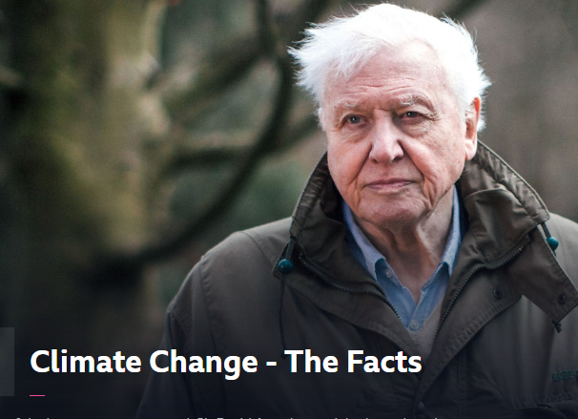**Task 3: Watch one of the TV programmes to give you context as to the problems mankind has brought to the planet over recent decades**

[**https://www.bbc.co.uk/iplayer/episode/m000mn4n/extinction-the-facts**](https://www.bbc.co.uk/iplayer/episode/m000mn4n/extinction-the-facts)

[**https://www.bbc.co.uk/iplayer/episode/m00049b1/climate-change-the-facts**](https://www.bbc.co.uk/iplayer/episode/m00049b1/climate-change-the-facts)

**What are the key lessons businesses take forward from the programme you watched? How will businesses need to change the way they operate in future years? Write up your findings.**

**Task 4: Pick one of the stories below where a well-known UK based business has been affected by the changing ethical values of society (or choose one of your own if you don’t find these interesting!)**

**Asos** [**https://www.bbc.co.uk/news/business-61822539**](https://www.bbc.co.uk/news/business-61822539)

**Missguided** [**https://www.bbc.co.uk/news/business-61784199**](https://www.bbc.co.uk/news/business-61784199)

**Amazon** [**https://www.bbc.co.uk/news/business-61790085**](https://www.bbc.co.uk/news/business-61790085)

**Harry Potter/Bloomsbury** [**https://www.bbc.co.uk/news/business-61808741**](https://www.bbc.co.uk/news/business-61808741)

**P&O** [**https://www.bbc.co.uk/news/business-61595745**](https://www.bbc.co.uk/news/business-61595745)

**Summarise the story by producing a 4 sided PowerPoint – try covering the WHO, WHAT, WHEN, WHY and WHAT of the story you are investigating.**

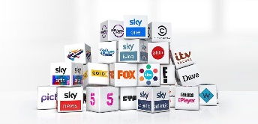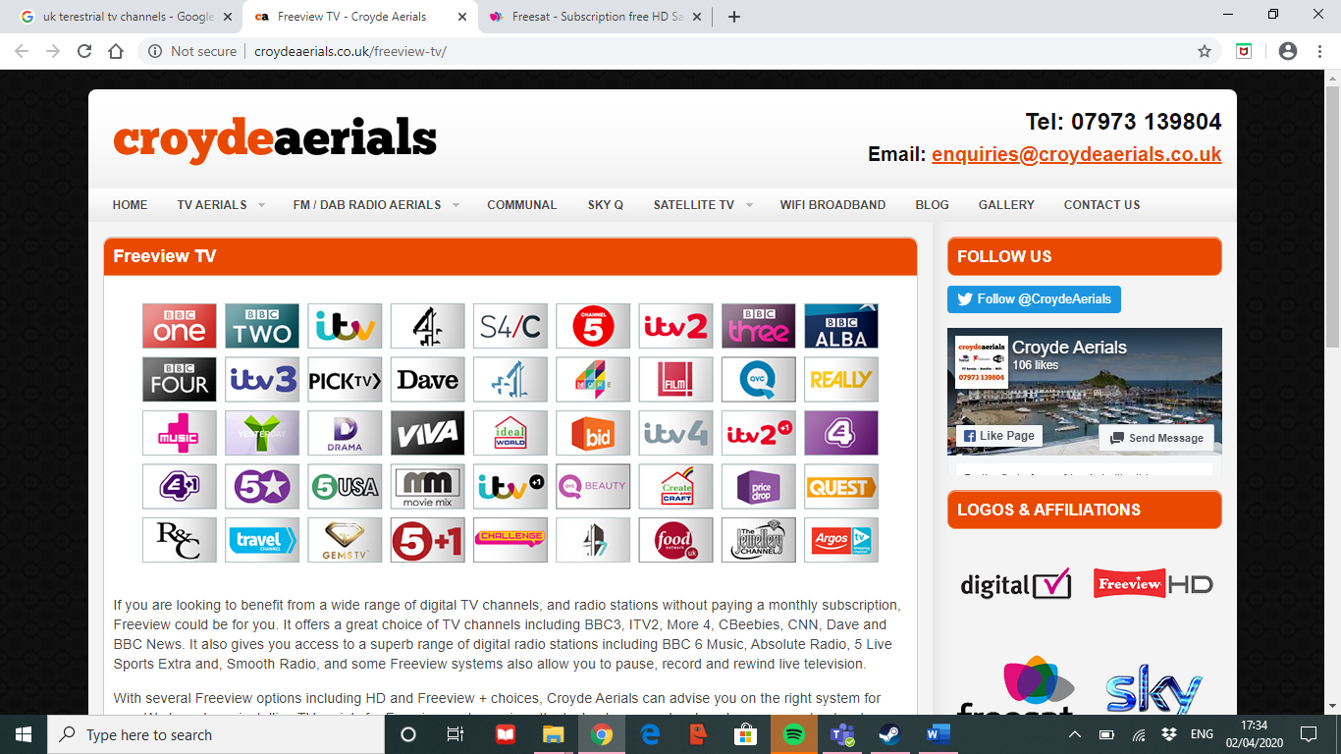**Task 5: Pick two or three of the business related TV/ films overleaf – there are loads to choose from. Channel 5 in particular, has some great business related content. This will again help you keep up to date with contemporary business events.**

|  |  |  |  |
| --- | --- | --- | --- |
| **BBC ITV Ch4 Ch5** | **Amazon Prime** | **Sky** | **Netflix** |
|  |  |  |  |
| The Nine to Five with Stacey Dooley - **BBC iPlayer** | The Founder | Erin Brockovich  ***Sky Movies*** | The Founder |
| Beauty Laid Bare - **BBC iPlayer** | Deepwater Horizon  (also see *Dirty Energy* for personal accounts from those affected) | The Little Pink House  ***Sky Movies*** | The Social Network |
| Panorama Amazon: what they know about us – **BBC** **iPlayer** | The Internship | Margin Call (can download from BBC via Sky) | The Big Short |
| Food unwrapped - **Ch4 on demand** | Pepsi vs Coke – | The Dark Knight | Moneyball |
| Inside Iceland: Britain’s Budget Supermarket - **Ch5 on demand** | Jobs Vs Gates: The Hippie and The Nerd | Moneyball | Mad Men |
| Tricky Business **Ch4**  on demand <https://www.channel4.com/programmes/tricky-business> | Facebook – Cracking the code | Silicon Valley – **Sky one** comedy | The True Cost |
| BBC Panorama Amazon The Truth Behind the Click <https://www.youtube.com/watch?v=JwrUYS9UTeU> | Starbucks unfiltered | Inside British Vogue **W** | Broken (ep2 The Big Vape) |
| The Hotel Inspector **Ch5 on demand** | Data centre - the true cost of the internet |  | Broken (ep 3 Deadly Dressers IKEA) |
| Dragon’s Den **BBC iPlayer** | Learn from the Experts - Jeff Bezos, Amazon Founder |  | Rotten Season 2 Ep1  The Avocado War |
| Inside the Factory **BBC iPlayer** | The Millennial Dream |  | Rotten Season 2 Ep3  Troubled Water |
| The Apprentice **BBC iPlayer** and YouTube | Business mindset for success |  | Rotten Season 2 Ep5  Bitter Chocolate |
| Toxic Town: The Corby Poisonings **BBC iPlayer** | Trump – What’s the deal? |  | Steve Jobs – Billion Dollar Hippie |
| Dispatches – Starbucks & Nespresso: The truth about your coffee **Ch4** | Small Business Revolution |  | Silicon Cowboys – story of Compaq |
|  |  |  | American Factory |
|  |  |  | Dirty Money – Season 1 Ep1 Hard NOx  (VW emissions fraud) |
|  |  |  | Dirty Money – Season 1 Ep4 Cartel Bank  (HSBC & Mexican cartels) |
|  |  |  | The Great Hack |
|  |  |  | Betting on Zero |
|  |  |  | Fyre – the greatest party that never happened |
|  |  |  | Shark Tank (Canadian version of Dragon’s Den) |

**Finally…..**…Enjoy the summer and your elongated break but don’t forget to keep yourself bang up to date with the business world so you come back ready to go. Looking forward to seeing you on your return. Good luck and see you in September

Mr Maloy/Mr Jones