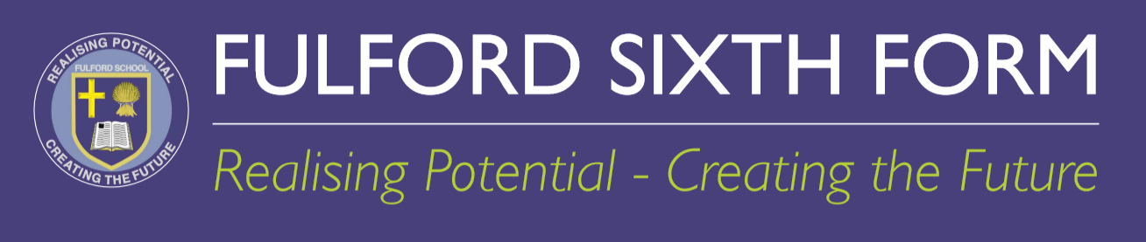

APPLYING TO JOIN FULFORD SIXTH FORM FROM SEPTEMBER 2026:

A guide for students currently not at Fulford School

November: Finding Out
FULFORD SIXTH FORM OPEN EVENING
Thursday 20th November 2025

Gather information through our promotional materials found on the website.
Apply for a place on one of the Taster Days.
The electronic booking form is on our Sixth Form website.

January: Experience
TASTER DAYS
13th and 15th January 2026
Come and experience life at Fulford Sixth Form for yourself.

By Feb: Apply
DEADLINE FOR ALL ON-LINE APPLICATIONS
Thursday 5th February 2026
Any change to this will be posted on our website.

April: Receive offer
Provisional offers sent out via Applicaa.

June: Transition
TRANSITION EVENT FOR PARENTS AND STUDENTS
Wednesday 17TH June 2026
Transition materials shared.

August Results Day: Offer confirmed or declined
RESULTS DAY:
Thursday 20th August 2026 by 12pm at the latest
Your results MUST be uploaded onto the Applicaa portal.
Should you wish to decline a place, please email Fulford Sixth Form.
Your offer is confirmed by us if all entry requirements have been met.

If you have any queries, please contact us on 01904 666406 or sixthform@fulford.york.sch.uk

