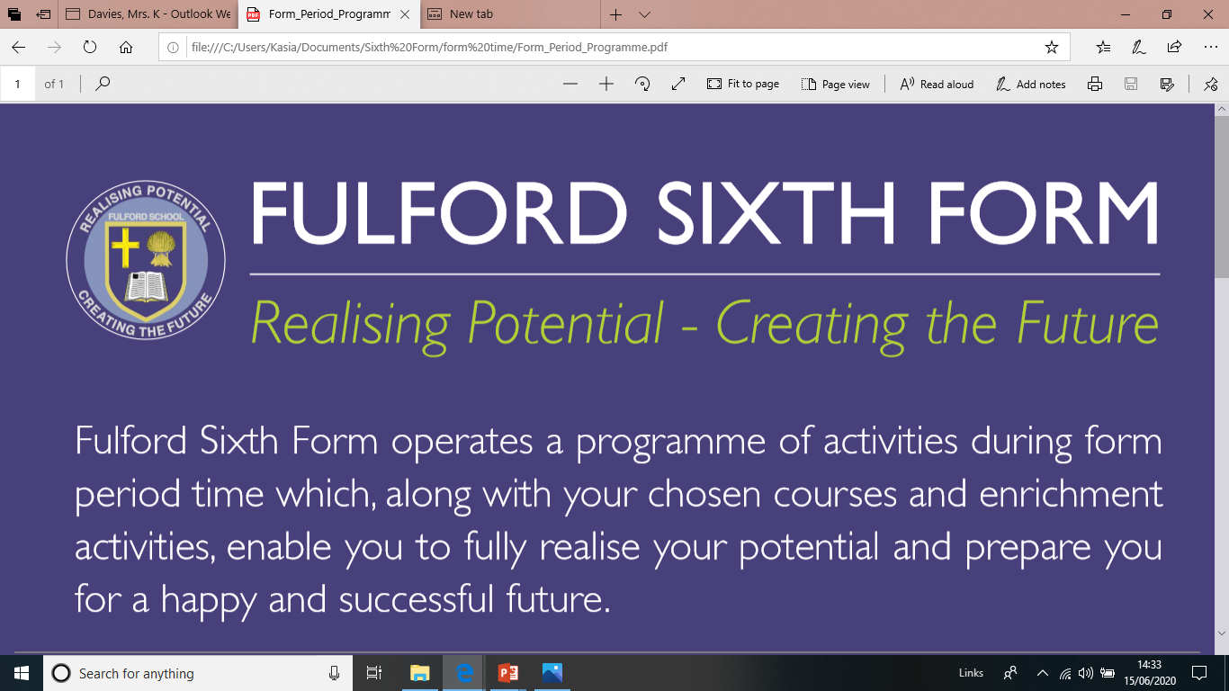

APPLYING TO JOIN FULFORD SIXTH FORM FROM SEPTEMBER 2026:

A guide for Fulford School students

November: Finding Out
FULFORD SIXTH FORM OPEN EVENING
Thursday 20th November 2025

Gather information through our promotional materials found on our website.
Use form-time to learn more about our Sixth Form.
Submit Taster Day booking form by Friday 7th November 2025.

December: Experience and Shaping the Options
TASTER DAY FOR INTERNAL STUDENTS ONLY
Friday 5th December 2025
Come and experience life at Fulford Sixth Form for yourself.
Dry-run option forms will be given out on this day.
Dry-run option forms submitted by Wednesday 17th December 2025.

January: Further Support
Student support: Year 11 Parents’ Evening and one-to-one Interviews
Final option forms issued to all students from Tuesday 13th January 2026.

By Feb: Apply
DEADLINE FOR APPLICATIONS
Thursday 5th February 2026
Any change to this will be posted on our website.

April: Receive offer
Provisional offers sent out.

June: Transition
TRANSITION EVENT FOR PARENTS AND STUDENTS
Wednesday 17TH June 2026
Transition materials shared.

August Results Day: Offer confirmed or declined
RESULTS DAY:
Thursday 20th August 2026
Your offer is confirmed by us if all entry requirements have been met.
You MUST inform us on Results Day by 1pm latest of your final decision.

If you have any queries, please contact us on 01904 666406 or sixthform@fulford.york.sch.uk

