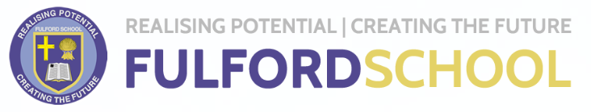

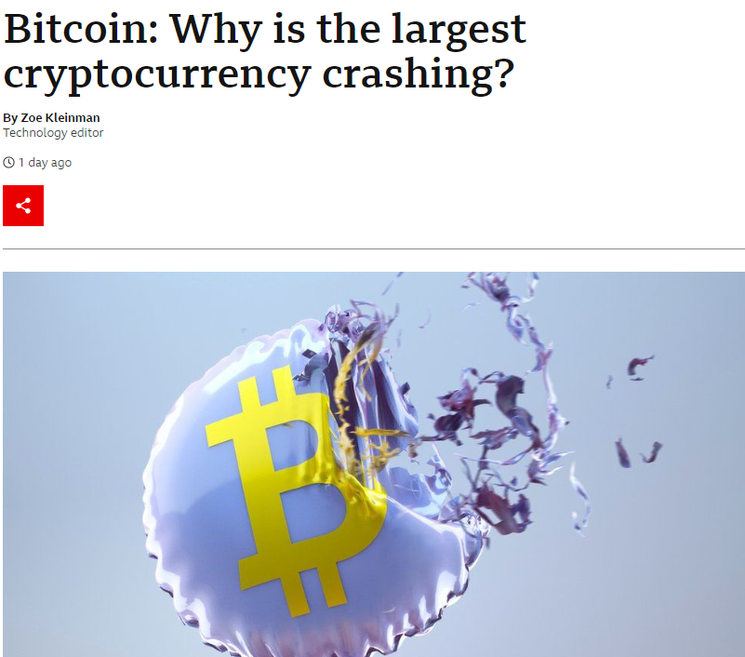
A Level Economics Transition Booklet
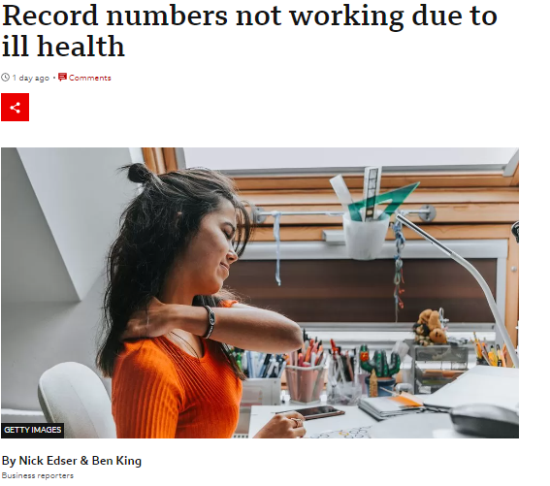

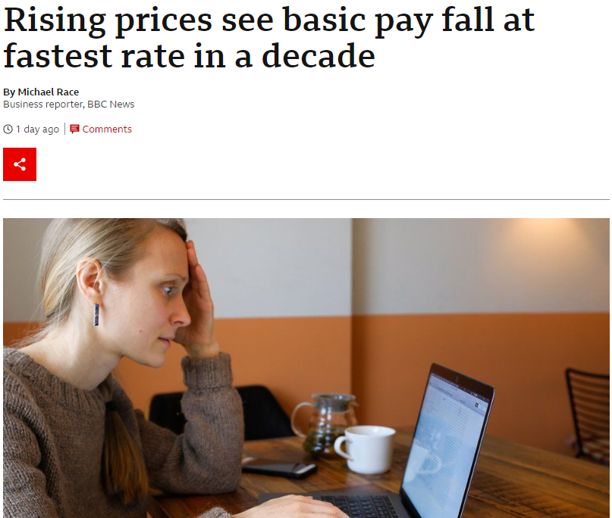
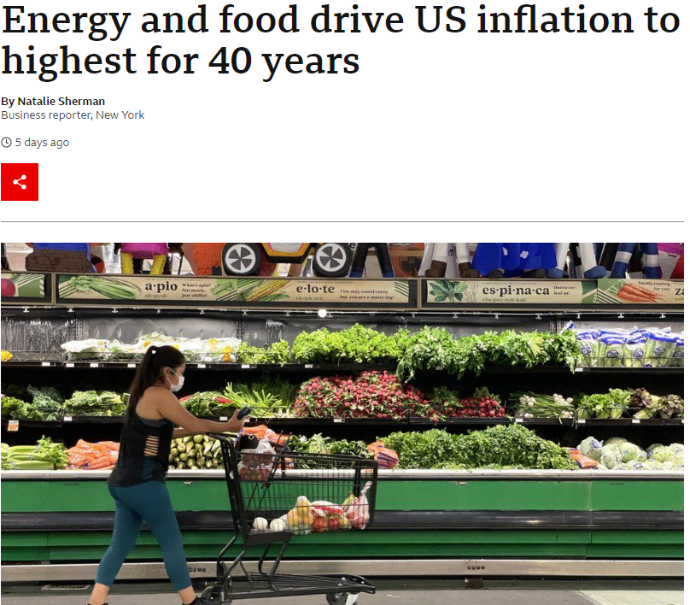

Welcome to A Level Economics
Congratulations and well done for completing your GCSEs and transitioning successfully onto the A Level Economics course at Fulford. As you are no doubt aware, the world is a pretty turbulent place right now, so there has not really been a more important or pertinent time to be studying Economics. The economic impact of events such as widespread inflationary pressures, the war in Ukraine and conflict in The Middle East and the continued impact of BREXIT makes this a very appropriate time to be studying the subject. Hopefully you have chosen Economics because you have a view on the way economies should operate and have an interest in the way the wider world and economies should solve major problems such as climate change and inequality for example. The UK government has recently supported households with soaring gas and electricity bills. On balance, what will be the economic impact of this in the UK for years to come? Should it be continued until prices fall? Should all households receive this support? Is this sustainable and what would be the alternative anyway? These are the types of problems economists are posed and tasked with finding the solutions for!

The basics
Economics boils down to 1 basic problem: Limited resources versus unlimited needs. In other words, the concept of scarcity and how “economic agents” have to make difficult choices - individuals, households, local and national governments are all affected by economics and have to make difficult decisions that can affect us all. For example, the UK government like many others around the world, is borrowing money to see the economy through the worst ravages of the current economic downturn. How should the government ultimately pay for this? Increased taxation? If so, which taxes should be raised and who should pay for the tax increases? The super-rich or all of us if we are truly “all in this together” Alternatively, some Economists talk about “spending their way out of recession” via an enormous “fiscal stimulus”. Do you think this is a better approach than an “austerity drive”, which some economists (but not all) think was the wrong approach by the UK government during the last economic crisis? If you were The Chancellor, charged with cutting spending in the UK, what budgets would you cut? Education, defence, The NHS or something else? This crystallises the difficult choices all of us have to make and is at the centre of the Economics course.

The expectations
Economics is a subject that continues to change, it is a forward looking subject. It is a subject that requires writing in context. You cannot rely only on a textbook alone. To be successful you will need to show:
- Awareness of economic issues in the real world via media news sources
- An ability to conduct independent research
- Show logical chains of argument and be able to weigh up evidence and make justified conclusions
Recommended reading and sources of information

Websites - great for A Level Economics theory:
- Tutor2u http://www.tutor2u.net/economics
- Economics Help http://www.economicshelp.org
- EconplusDal http://www.econplusdal.com
- Economics Online http://www.economicsonline.co.uk/
- The Royal Economics Society https://www.res.org.uk/
- Why Study Economics https://whystudyeconomics.ac.uk/

Great for economics in the news:
- BBC News (economy section) http://www.bbc.co.uk/news/business/economy
- The Guardian (economics section) https://www.theguardian.com/business/economics
- The Financial Times https://www.ft.com/
- Highly recommended – David Smith, Sunday Times Business Section – each Sunday a great Economics based article is provided David Smith's EconomicsUK.com

Recommended YouTube channels
- Tutor2u Economics https://www.youtube.com/channel/UCe83jLdZ3PuqVwAHe6B3U2A
- G Conomics https://www.youtube.com/channel/UCzTsouXeGOAwePw-KAalRhA
- EconomicsplusDal https://www.youtube.com/user/EconplusDal

Social media feeds – eg Instagram, TikTok, Twitter etc)
- G Conomics
- Economicsplus
- Economics in Ten
- The Economist
- DSmith Economics
Great for economics data:
- Trading Economics http://www.tradingeconomics.com

Books:
- Can’t We Just Print More Money by Rupal Patel
- Economics: The User's Guide: A Pelican Introduction by Ha-Joon Chang
- Cracking Economics by Tejvan Pettinger
- Freakonomics: A Rogue Economist Explores the Hidden Side of Everything by Levitt, Steven D., Dubner
- The Undercover Economist by Tim Harford
- The Euro by Joseph Stiglitz
- Capital in the Twenty First Century by Thomas Piketty
- Doughnut Economics by Kate Raworth
- GDP: A Brief but Affectionate History by Professor Diane Coyle

Magazines:
- Economic Review
- The Economist

Films:
- The Big Short (2015) – biographical drama-comedy film
- Margin Call (2011) – drama film
- Rogue Trader (1999) – biographical drama film
- Boiler Room (2000) – crime, drama film
- Wall Street (1987) – drama film
- Enron: The Smartest Guys in the Room (2005) - documentary
- Inside Job (2010) – documentary

Task 1:
Your first task is to organise your online content so that you have resources at hand for your A- Level Economics course. Follow social media feeds and also add the websites to your favourites list or download some Economics based apps. Also the add Economics in the News & YouTube channels links too. You will now be in a great position to keep up to date with contemporary Economics articles as well as have resources close at hand when you need them.

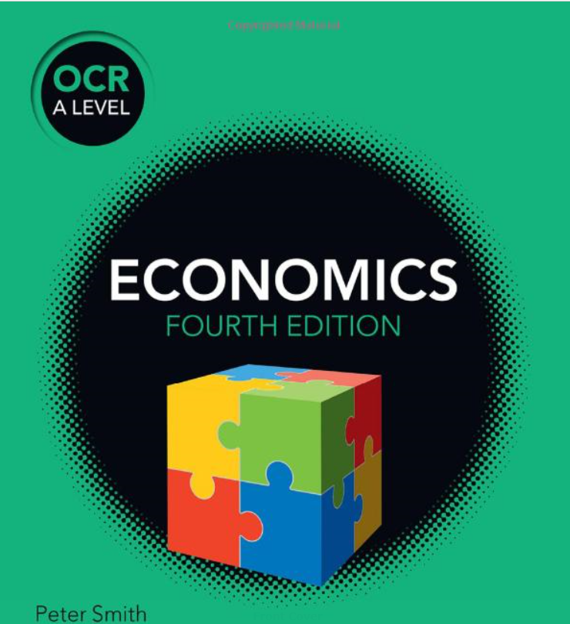
Task 2: Recommended course textbook – we strongly advise you buy the recommended Economics textbook endorsed by OCR - the exam board we follow. Although it is quite expensive, it will be absolutely invaluable for the course and is an excellent sources of information that matches the specification very closely.
Book title: OCR A Level Economics (4th edition) Paperback – 30 Aug 2019
https://www.amazon.co.uk/OCR-Level-Economics-Peter-Smith/dp/1510458409 £40.00

You may be able to get it cheaper elsewhere (in Economics, we learn that prices are influenced by supply and demand) so shop around for the best deal! Some used copies from eBay or other “pre-loved” websites may offer you better value for money.

Task 3: Download and print off the course specification – the pages you need are pages 8-24. Set up an Economics folder and put the print out at the front of your folder for future reference – have a look at the topics you will be covering in the first few months and read around the subject, using some of the websites detailed previously.
https://www.ocr.org.uk/Images/536455-specification-accredited-a-level-gce-economics-h460.pdf

Topical Economics:
Economics is all around you and we are now going to look at a prominent Economics topic that is affecting the UK – inflation.

Task 4: UK inflation (use the link below and other information sources to help you answer the questions set):
https://www.bbc.co.uk/news/business-12196322
The UK, like many economies, is experiencing rising levels of inflation. Answer the following questions:
- What is meant by the term inflation?
- How is inflation measured? What is meant by a “basket of goods” being used to help measure inflation. Inflation can erode real pay. Explain what is meant by real levels of pay.
- Using the link above, explain what has happened to inflation rates since 2020. Find a graph or chart and numerically analyse the trends.
- Outline the main reasons for increased inflation rates in the UK over the last two years – what are the key drivers or factors that have contributed to inflation over recent months. Produce a spider diagram to illustrate your answer.
- What is meant by real pay? What has been the impact of inflation on real pay due to inflation trends you identified? Are the trends good or bad news for the UK economy? Justify your answer.
- Outline the measures the UK government has put in place to try and alleviate the effects of inflation on the economy. Produce a spider diagram to illustrate your answer.
- In Economics, inflation can either be cost push or demand pull in nature. Explain the difference between these types of inflation.
- Is current inflation being caused by cost push or demand-pull factors. Justify your answer.


Task 5: Pick 2 of the Economics related films detailed earlier in the booklet. This will again help you gain a flavour of the subject. Use the suggested film list in this handout and pick out 2 that you would like to watch. There may be other Economics related movies that appeal to you too. Let us know if you find any other ones we can add to the list! You will probably need to use a streaming site or YouTube to access these.


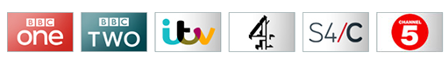

Finally…..enjoy the summer and your elongated break but don’t forget to keep yourself bang up to date with the world of Economics using all the information sources provided so you come back ready to go. Looking forward to seeing you on your return. Good luck and see you in September.

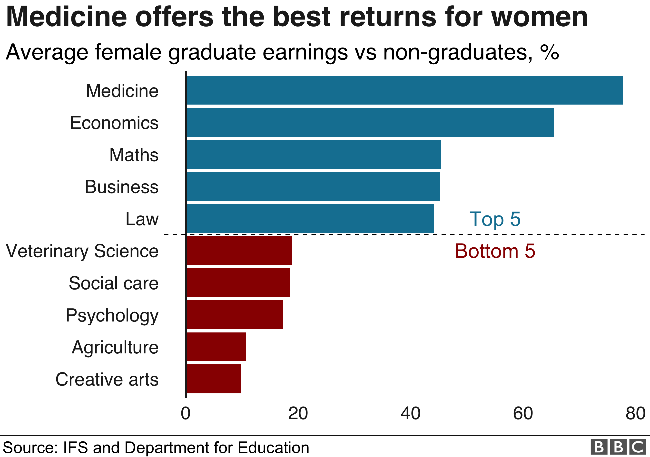
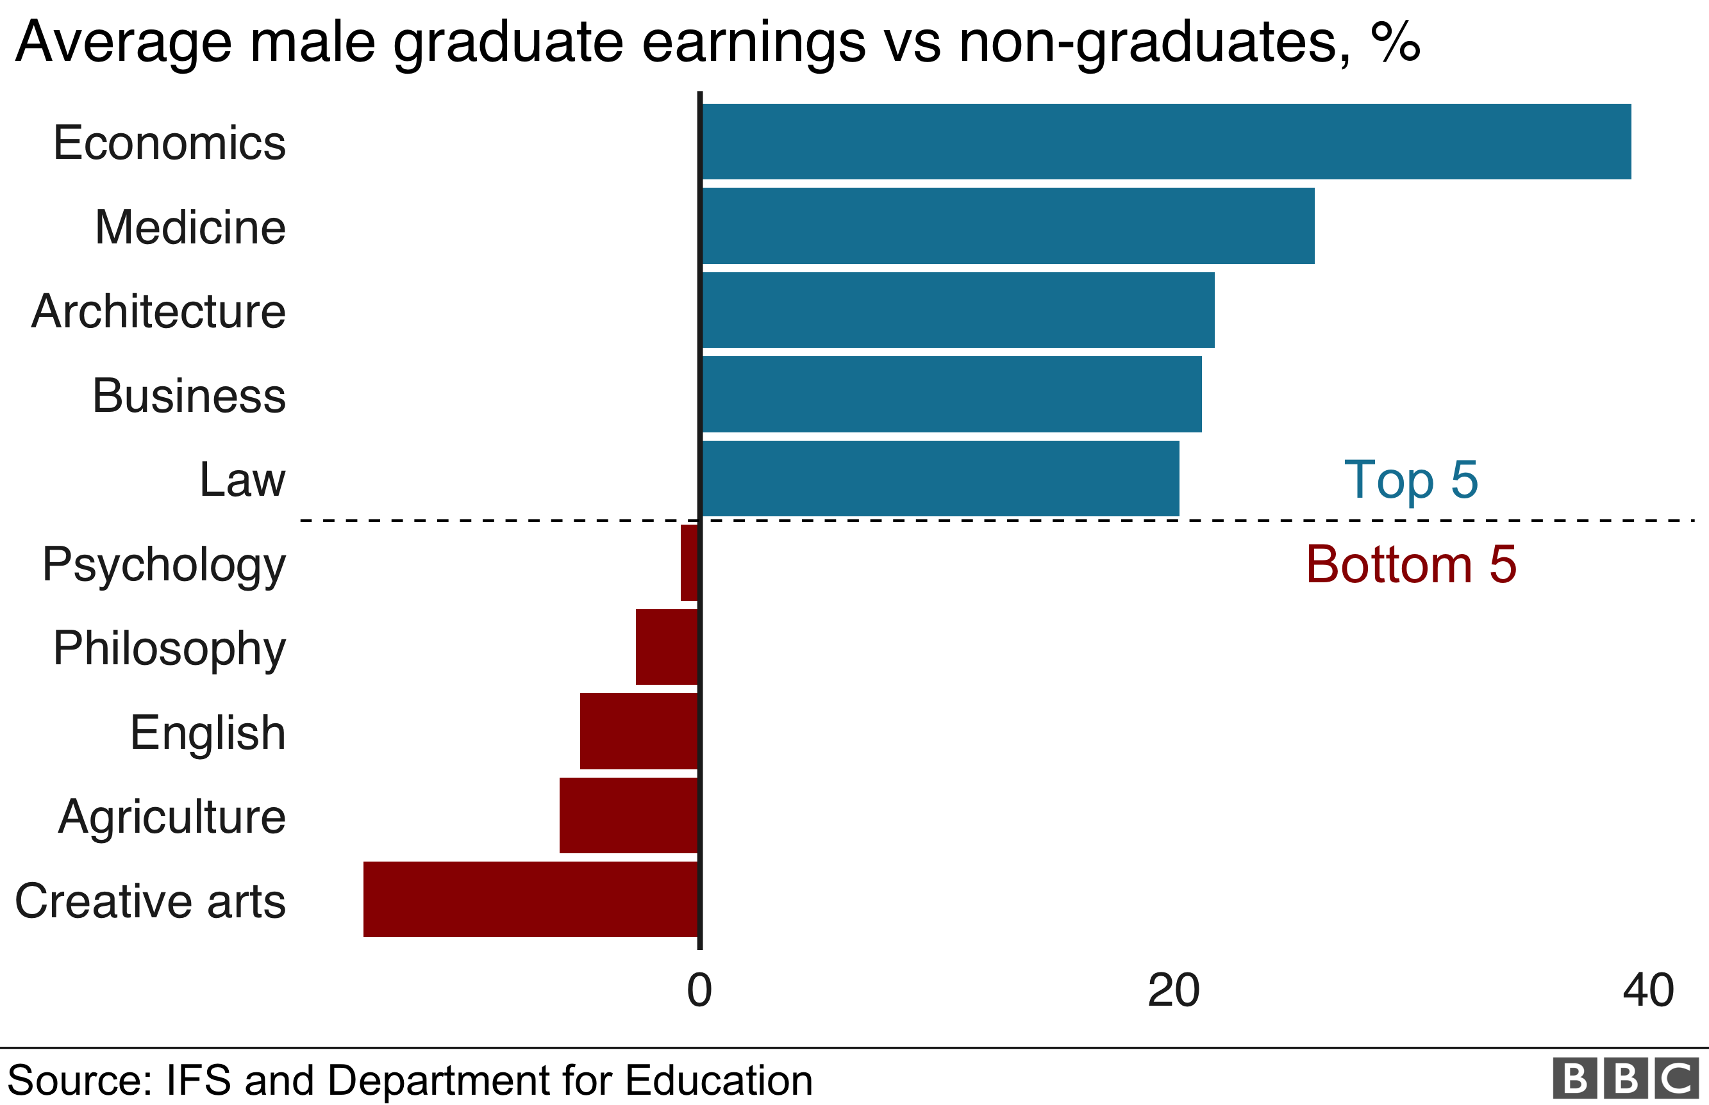
Mr Maloy/Mr Wright

