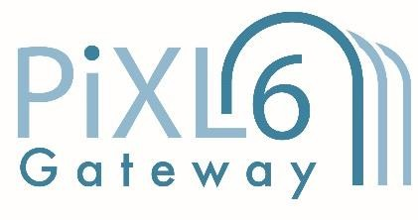

Transition Pack for A Level Chemistry

Get ready for A-level!
A guide to help you get ready for A-level Chemistry, including everything from topic guides to days out and online learning courses.

Commissioned by The PiXL Club Ltd. April 2018

© Copyright The PiXL Club Ltd, 2018

Please note: these resources are non-board specific. Please direct your students to the specifics of where this knowledge and skills most apply.
This resource is strictly for the use of member schools for as long as they remain members of The PiXL Club. It may not be copied, sold nor transferred to a third party or used by the school after membership ceases. Until such time it may be freely used within the member school.

All opinions and contributions are those of the authors. The contents of this resource are not connected with nor endorsed by any other company, organisation or institution. www.pixl.org.uk The PiXL Club Ltd, Company number 07321607

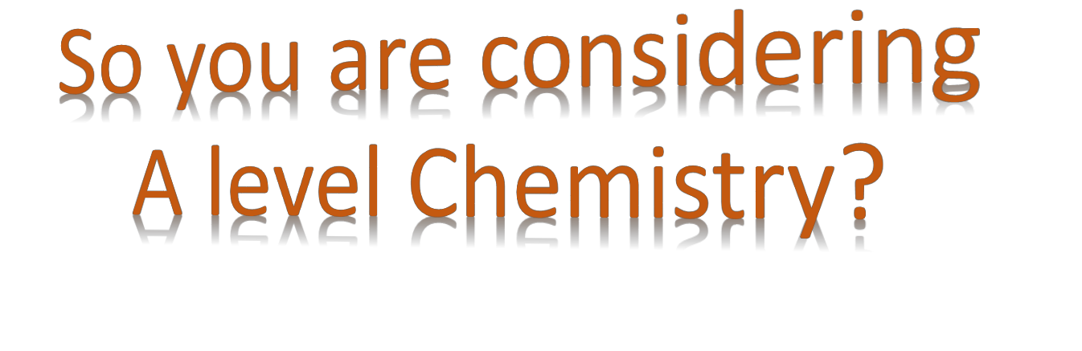This pack contains a programme of activities and resources to prepare you to start A level in Chemistry in September. It is aimed to be used after you complete your GCSE, throughout the remainder of the summer term and over the summer holidays to ensure you are ready to start your course in September.

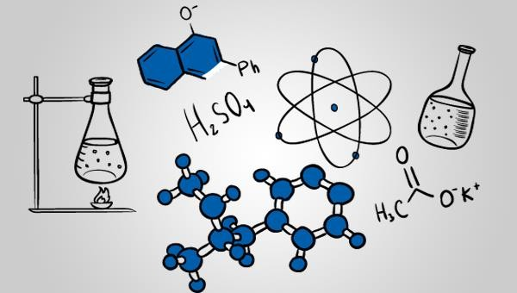

https://www.my-mooc.com/en/mooc/chemistry1/


Kick back this summer with a good read. The books below are all popular science books and great for extending your understanding of chemistry

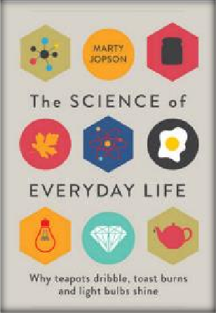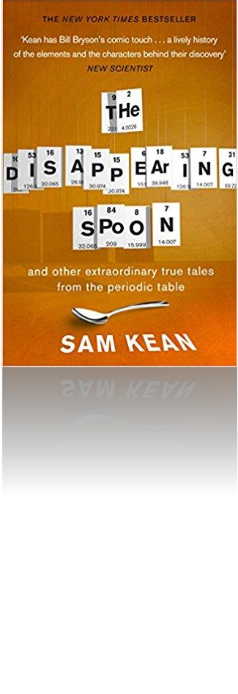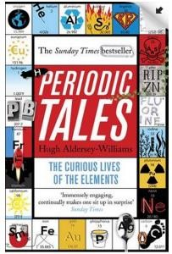The Science of Everyday Life: Why Teapots Dribble, Toast Burns and Light Bulbs Shine

Periodic Tales: The Curious Lives of the Elements
This book covers the chemical elements, where they come from and how they are used. There are loads of fascinating insights into uses for chemicals you would have never even thought about.
The title says it all really, lots of interesting stuff about the things around your home!

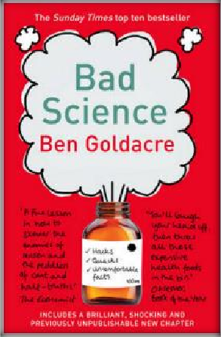Bad Science
Here Ben Goldacre takes apart anyone who published bad / misleading or dodgy science – this book will make you think about everything the advertising industry tries to sell you by making it sound ‘sciencey’.



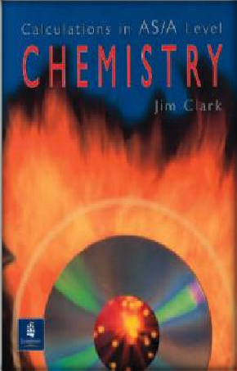Calculations in AS/A Level Chemistry
If you struggle with the calculations side of chemistry, this is the book for you. Covers all the possible calculations you are ever likely to come across. Brought to you by the same guy who wrote the excellent chemguide.co.uk website.

© Copyright The PiXL Club Ltd, 2018

One of our crowning scientific achievements is also a treasure trove of passion, adventure, betrayal and obsession. The Disappearing Spoon follows the elements, their parts in human history, finance, mythology, conflict, the arts, medicine and the lives of the (frequently) mad scientists who discovered them.

Everyone loves a good story and everyone loves some great science. Here are some of the picks of the best films based on real life scientists and discoveries. You wont find Jurassic Park on this list! We’ve looked back over the last 50 years to give you our top 5 films you might not have seen before. Great watching for a rainy day.


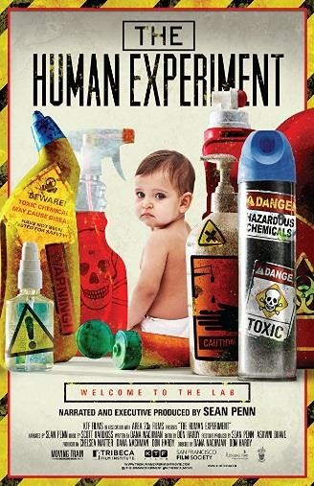
The Human Experiment (2013)
A documentary that explores chemicals found in everyday household products.

An Inconvenient Truth (2006)
Al Gore, former presidential candidate campaigns to raise public awareness of the dangers of global warming and calls for immediate action to curb its destructive effects on the environment.

(See also: An Inconvenient Sequel, 2017)

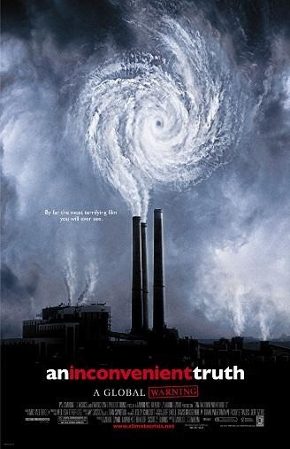

Erin Brokovich (2000) Based on a true story. An unemployed single mother becomes a legal assistant and almost single-handedly brings down a California power company accused of polluting a city's water supply.

A Civil Action (1998)
A tenacious lawyer takes on a case involving a major company responsible for causing several people to be diagnosed with leukemia due to the town's water supply being contaminated, at the risk of bankrupting his firm and career.
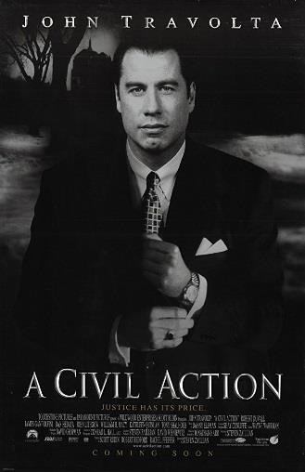


The Insider (1999)
A research chemist comes under personal and professional attack when he decides to appear in a "60 Minutes" expose on Big Tobacco.

If you have 30 minutes to spare, here are some great presentations (and free!) from world leading scientists and researchers on a variety of topics. They provide some interesting answers and ask some thought-provoking questions. Use the link or scan the QR code to view:

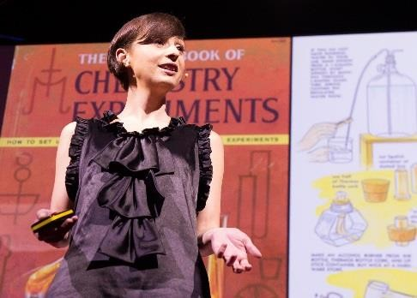

Play with Smart Materials
Available at : https://www.ted.com/talks/catarina_mota
_play_with_smart_materials Ink that conducts electricity; a window that turns from clear to opaque at the flip of a switch; a jelly that makes music. All this stuff exists, it's time to play with it. A tour of surprising and cool new materials.


Just how small is an atom?
Available at : https://www.ted.com/talks/just_how_small_i s_an_atom
Just how small are atoms? Really, really, really small. This fast-paced animation from TED-Ed uses metaphors (imagine a blueberry the size of a football stadium!) to give a visceral sense of just how small atoms are.


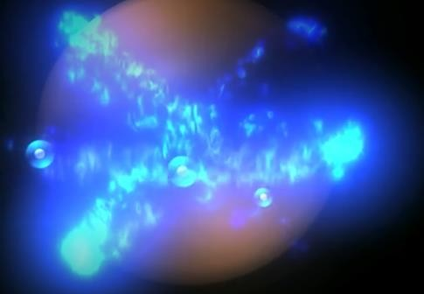
Battling Bad Science
Available at : https://www.ted.com/talks/ben_goldacre
_battling_bad_science#t-44279
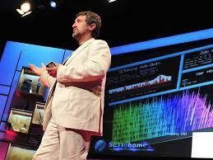

Every day there are news reports of new health advice, but how can you know if they're right? Doctor and epidemiologist Ben Goldacre shows us, at high speed, the ways evidence can be distorted, from the blindingly obvious nutrition claims to the very subtle tricks of the pharmaceutical industry.


How Spectroscopy Could Reveal Alien Life Available at : https://www.ted.com/talks/garik_israelian
_what_s_inside_a_star
Garik Israelian is a spectroscopist, studying the spectrum emitted by a star to figure out what it's made of and how it might behave. It's a rare and accessible look at this discipline, which may be coming close to finding a planet friendly to life.

Research, reading and note making are essential skills for A level chemistry study. For the
following task you are going to produce ‘Cornell Notes’ to summarise your reading.

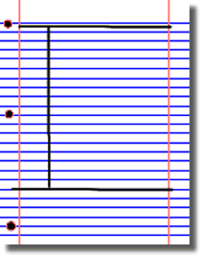
- Divide your page into three sections like this

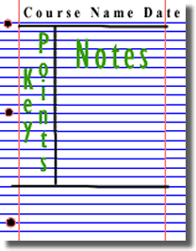
3. Use the large box to make notes. Leave a space between separate idea. Abbreviate where possible.

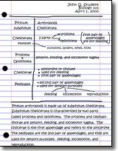
5. Write a summary of the main ideas in the bottom space
- Write the name, date and topic at the top of the page

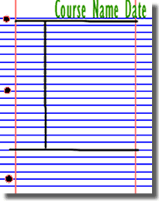
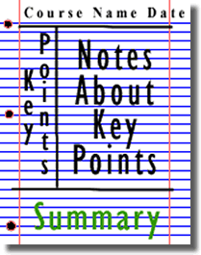
4. Review and identify the key points in the left hand box

Images taken from http://coe.jmu.edu/learningtoolbox/cornellnotes.html


Aimed at students aged 14-19, Catalyst magazine is packed with interesting articles on cutting-edge science, interviews and new research written by leading academics. It also includes a booklet of teacher's notes, full of ideas and lesson plans to bring the articles to life in the classroom.
For each of the following topics you are going to use the resources to produce one page of Cornell style notes.
Use the links of scan the QR code to take you to the resources.

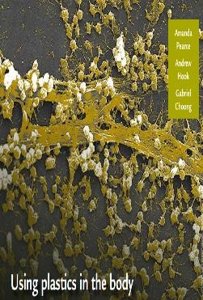

Topic 1: Using Plastics in the Body Available at:
https://www.stem.org.uk/resources/elibrary/resourc e/382317/using-plastics-body
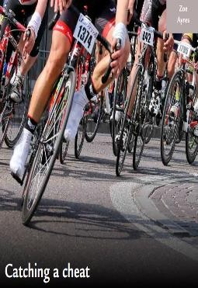
This Catalyst article looks at how scientists are learning to use polymers for many medical applications, including implants, bone repairs and reduction in infections.



Topic 2: Catching a Cheat Available at:
https://www.stem.org.uk/system/files/elibrary- resources/2017/03/Catching%20a%20cheat.pdf This Catalyst article looks at analytical chemists who are involved in many kinds of testing, including drug testing to catch cheats in sport.

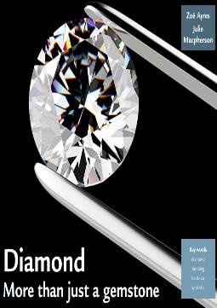

Topic 3: Diamond: More than just a gemstone Available at: https://www.stem.org.uk/system/files/elibrary- resources/2017/02/Diamond%20more%20than%20j ust%20a%20gemstone.pdf
This Catalyst article looks at diamond and graphite which are allotropes of carbon. Their properties, which depend on the bonding between the carbon atoms, are also examined.

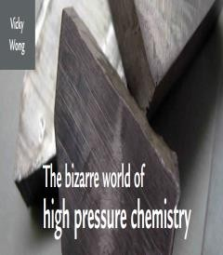

Topic 4: The Bizarre World of High Pressure Chemistry
Available at: https://www.stem.org.uk/system/files/elibrary- resources/2016/11/Catalyst27_1_the_bizarre_world
_of_high_pressure_chemistry.pdf
This Catalyst article investigates high pressure chemistry and discovers that, when put under extreme pressure, the properties of a material may change dramatically.

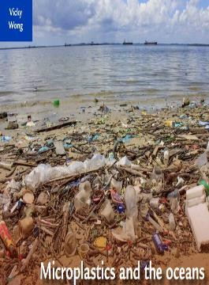

Topic 5: Microplastics and the Oceans Available at:
https://www.stem.org.uk/system/files/elibrary- resources/2016/11/Catalyst27_1_microplastics_%20 and_the_oceans.pdf
This Catalyst article looks at microplastics. Microplastics are tiny particles of polymer used in many products. They have been found to be an environmental pollutant especially in oceans.



A level chemistry will use your knowledge from GCSE and build on this to help you understand new and more demanding ideas. Complete the following tasks to make sure your knowledge is up to date and you are ready to start studying:
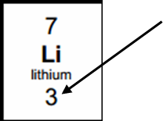
Chemistry Topic 1 – Electronic structure, how electrons are arranged around the nucleus
A periodic table can give you the proton / atomic number of an element, this also tells you how many electrons are in the atom.
You will have used the rule of electrons shell filling, where:
The first shell holds up to 2 electrons, the second up to 8, the third up to 8 and the fourth up to 18 (or you may have been told 8).
Atomic number =3, electrons = 3, arrangement 2 in the first shell and 1 in the second or Li = 2,1

At A level you will learn that the electron structure is more complex than this and can be used to explain a lot of the chemical properties of elements.
The ‘shells’ can be broken down into ‘orbitals’, which are given letters: ‘s’ orbitals, ‘p’ orbitals and ‘d’ orbitals.
You can read about orbitals here:
http://bit.ly/pixlchem1 http://www.chemguide.co.uk/atoms/properties/atomorbs.html#top

Now that you are familiar with s, p and d orbitals try these problems. Write your answer in the format: 1s2, 2s2, 2p6 etc.
Q1. Write out the electron configuration of:
a) Ca b) Al c) S d) Cl e) Ar f) Fe g) V h) Ni i) Cu j) Zn k) As Q2. Extension question, can you write out the electron arrangement of the following ions:
a) K+ b) O2- c) Zn2+ d) V5+ e) Co2+

Chemistry Topic 2 – Oxidation and reduction
At GCSE you learnt that oxidation is adding oxygen to an atom or molecule and that reduction is removing oxygen, or that oxidation is removing hydrogen and reduction is adding hydrogen. You may have also learnt that oxidation is removing electrons and reduction is adding electrons.
At A level we use the idea of oxidation number a lot!
You know that the metals in group 1 react to form ions that are +1, i.e. Na+ and that group 7, the halogens, form -1 ions, i.e. Br -.
We say that sodium, when it has reacted, has an oxidation number of +1 and that bromide has an oxidation number of -1. All atoms that are involved in a reaction can be given an oxidation number.
An element, Na or O2, is always given an oxidation state of zero (0). Any element that has reacted has an oxidation state of
+ or -.
As removing electrons is reduction, if, in a reaction the element becomes more negative it has been reduced, if it becomes more positive it has been oxidised.

-5 0 +5
You can read about the rules for assigning oxidation numbers here:
http://www.dummies.com/how-to/content/rules-for-assigning-oxidation-numbers-to-elements.html

f) V2O5
e) Fe2O3
d) MnO2
c) NaClO3
i) Cl2O4
2-
h) Cr2O7
b) SO3
a) MgCO3
g) KMnO4
Q2. Work out the oxidation state of the underlined atom in the following:
S = +6
N = +5
To cancel:
-2
-8
4xO2- and 2- charges ‘showing’
3x O2-
-6
Na +1
+1
2-
sulfate ion, SO4
Examples: Sodium nitrate, NaNO3
Elements that you expect to have a specific oxidation state actually have different states, so for example you would expect
chlorine to be -1. It can have many oxidation states: NaClO, in this compound it has an oxidation state of +1 There are a few simple rules to remember:
Metals have a + oxidation state when they react.
Oxygen is ‘king’, it always has an oxidation state of -2. Hydrogen has an oxidation state of +1 (except metal hydrides). The charges in a molecule must cancel.

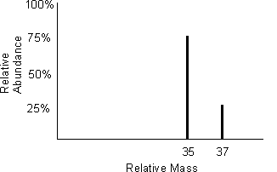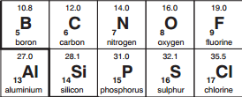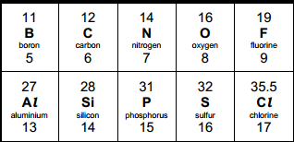Chemistry Topic 3 – Isotopes and mass
You will remember that isotopes are elements that have differing numbers of neutrons. Hydrogen has 3 isotopes; 𝐻¹
1
𝐻² 𝐻³
1 1
Isotopes occur naturally, so in a sample of an element you will have a mixture of these isotopes. We can accurately
measure the amount of an isotope using a mass spectrometer. You will need to understand what a mass spectrometer is and how it works at A level. You can read about a mass spectrometer here:

http://bit.ly/pixlchem3 http://www.kore.co.uk/tutorial.htm http://bit.ly/pixlchem4
http://filestore.aqa.org.uk/resources/chemistry/AQA-7404-7405-TN-MASS-SPECTROMETRY.PDF

Q1. What must happen to the atoms before they are accelerated in the mass spectrometer? Q2. Explain why the different isotopes travel at different speeds in a mass spectrometer.
A mass spectrum for the element chlorine will give a spectrum like this:
75% of the sample consist of chlorine-35, and 25% of the sample is chlorine-37.
Given a sample of naturally occurring chlorine, ¾ of it
will be Cl-35 and ¼ of it is Cl-37. We can calculate what the mean mass of the sample will be:
Mean mass = 75 x 35 + 25 x 37 = 35.5
100 100

If you look at a periodic table, this is why chlorine has an atomic mass of 35.5.
An A level periodic table has the masses of elements recorded much more accurately than at GCSE. Most elements have isotopes and these have been recorded using mass spectrometers.

GCSE A Level

Given the percentage of each isotope you can calculate the mean mass which is the accurate atomic mass for that element.
Q3. Use the percentages of each isotope to calculate the accurate atomic mass of the following elements.
- Antimony has 2 isotopes: Sb-121 57.25% and Sb-123 42.75%
- Gallium has 2 isotopes: Ga-69 60.2% and Ga-71 39.8%
- Silver has 2 isotopes: Ag-107 51.35% and Ag-109 48.65%
- Thallium has 2 isotopes: Tl-203 29.5% and Tl-205 70.5%
e. Strontium has 4 isotopes: Sr-84 0.56%, Sr-86 9.86%, Sr-87 7.02% and Sr-88 82.56%

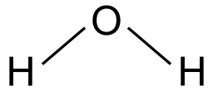
Chemistry Topic 4 – The shapes of molecules and bonding
Have you ever wondered why your teacher drew a water molecule like this? The lines represent a covalent bond, but why draw them at an unusual angle? If you are unsure about covalent bonding, read about it here:

http://bit.ly/pixlchem5 http://www.chemguide.co.uk/atoms/bonding/covalent.html#top

At A level you are also expected to know how molecules have certain shapes and why they are the shape they are. You can read about shapes of molecules here:

http://bit.ly/pixlchem6 http://www.chemguide.co.uk/atoms/bonding/shapes.html#top

Q1. Draw a dot and cross diagram to show the bonding in a molecule of aluminium chloride (AlCl3) Q2. Draw a dot and cross diagram to show the bonding in a molecule of ammonia (NH3)
Q3. What is the shape and the bond angles in a molecule of methane (CH4)?

Chemistry Topic 5 – Chemical equations
Balancing chemical equations is the stepping stone to using equations to calculate masses in chemistry. There are loads of websites that give ways of balancing equations and lots of exercises in balancing.
Some of the equations to balance may involve strange chemicals- don’t worry about that, the key idea is to get balancing
right.

http://bit.ly/pixlchem7 http://www.chemteam.info/Equations/Balance-Equation.html
This website has a download; it is safe to do so: http://bit.ly/pixlchem8
https://phet.colorado.edu/en/simulation/balancing-chemical-equations

Q5. Balance the following equations a. H2 + 02→ H20
b. S8+ 02→ S03
- HgO → Hg+ 02
- Zn+ HCl→ ZnCl2+ H2
- Na+ H20 → NaOH + H2
- C10H16+ CI2 → C + HCl
g. Fe+ 02→ Fe203
h. C6H1206+ 02→ C02+ H20 i. Fe203 + H2 → Fe + H20
j. Al + FeO → Al2O3 + Fe

Chemistry Topic 6 – Measuring chemicals – the mole
From this point on you need to be using an A level periodic table, not a GCSE one. You can view one here:

http://bit.ly/pixlpertab
https://secondaryscience4all.files.wordpress.com/2014/08/filestore_aqa_org_uk_subjects_aqa-2420-w-trb-ptds_pdf.png

Now that we have our chemical equations balanced, we need to be able to use them in order to work out masses of chemicals we need or we can produce.
The mole is the chemists equivalent of a dozen. Atoms are so small that we cannot count them out individually, we weigh out chemicals.
For example: magnesium + sulfur → magnesium sulfide
Mg + S → MgS
We can see that one atom of magnesium will react with one atom of sulfu. If we had to weigh out the atoms we need to know how heavy each atom is.
From the periodic table: Mg = 24.3 and S = 32.1
If I weigh out exactly 24.3g of magnesium this will be 1 mole of magnesium. If we counted how many atoms were present in this mass it would be a huge number (6.02 x 1023!!!!). If I weigh out 32.1g of sulfur then I would have 1 mole of sulfur atoms.
So 24.3g of Mg will react precisely with 32.1g of sulfur, and will make 56.4g of magnesium sulfide.
Here is a comprehensive page on measuring moles, there are a number of descriptions, videos and practice problems. You will find the first 6 tutorials of most use here, and problem sets 1 to 3.

http://bit.ly/pixlchem9 http://www.chemteam.info/Mole/Mole.html

Q1. Answer the following questions on moles.
How many moles of phosphorus pentoxide (P4O10) are in 85.2g?
How many moles of potassium are in 73.56g of potassium chlorate (V) (KClO3)?
How many moles of water are in 249.6g of hydrated copper sulfate(VI) (CuSO4.5H2O)? For this one, you need to be aware the dot followed by 5H2O means that the molecule comes with 5 water molecules so these have to be counted in as part of the molecules mass.
What is the mass of 0.125 moles of tin sulfate (SnSO4)?
If I have 2.4g of magnesium, how many g of oxygen(O2) will I need to react completely with the magnesium? 2Mg +O2 →
MgO
Chemistry Topic 7 – Solutions and concentrations
In chemistry a lot of the reactions we carry out involve mixing solutions rather than solids, gases or liquids. You will have used bottles of acids in science that have labels saying ‘Hydrochloric acid 1M’, this is a solution of hydrochloric acid where 1 mole of HCl, hydrogen chloride (a gas) has been dissolved in 1dm3 of water.
The dm3 is a cubic decimetre, it is actually 1 litre but from this point on as an A level chemist you will use the dm3 as your volume measurement.

http://bit.ly/pixlchem10 http://www.docbrown.info/page04/4_73calcs11msc.htm

Q1.
- What is the concentration (in mol dm-3) of 9.53g of magnesium chloride (MgCl2) dissolved in 100cm3 of water?
- What is the concentration (in mol dm-3) of 13.248g of lead nitrate (Pb(NO3)2) dissolved in 2dm3 of water?
- If I add 100cm3 of 1.00 mol dm3 HCl to 1.9dm3 of water, what is the molarity of the new solution?
- What mass of silver is present in 100cm3 of 1moldm-3 silver nitrate (AgNO3)?
- The Dead Sea, between Jordan and Israel, contains 0.0526 moldm-3 of Bromide ions (Br -). What mass of bromine is in
1dm3 of Dead Sea water?

Chemistry topic 8 – Titrations
One key skill in A level chemistry is the ability to carry out accurate titrations. You may well have carried out a titration at GCSE, at A level you will have to carry them out very precisely and be able to describe in detail how to carry out a titration - there will be questions on the exam paper about how to carry out practical procedures.
You can read about how to carry out a titration here, the next page in the series (page 5) describes how to work out the concentration of the unknown.

http://bit.ly/pixlchem11 http://www.bbc.co.uk/schools/gcsebitesize/science/triple_aqa/further_analysis/analysing_substances/revision/4/

Remember for any titration calculation you need to have a balanced symbol equation; this will tell you the ratio in which the chemicals react.
E.g. a titration of an unknown sample of sulfuric acid with sodium hydroxide.
A 25.00cm3 sample of the unknown sulfuric acid was titrated with 0.100moldm-3 sodium hydroxide and required exactly 27.40cm3 for neutralisation. What is the concentration of the sulfuric acid?

Step 1: the equation 2NaOH + H2SO4 → Na2SO4 + 2H2O
Step 2: the ratios 2 : 1
Step 3: how many moles of sodium hydroxide 27.40cm3 = 0.0274dm3 number of moles = c x v = 0.100 x 0.0274 = 0.00274 moles
step 4: using the ratio, how many moles of sulfuric acid
for every 2 NaOH there are 1 H2SO4 so, we must have 0.00274/2 =0.00137 moles of H2SO4
Step 5: calculate concentration. concentration = moles/volume ←in dm3 = 0.00137/0.025 = 0.0548 moldm-3
Here are some additional problems which are harder, ignore the questions about colour changes of indicators. http://bit.ly/pixlchem12
http://www.docbrown.info/page06/Mtestsnotes/ExtraVolCalcs1.htm

Use the steps on the last page to help you.
Q1. A solution of barium nitrate will react with a solution of sodium sulfate to produce a precipitate of barium sulfate. Ba(NO3)2(aq) + Na2SO4(aq) → BaSO4(s) + 2NaNO3(aq)
What volume of 0.25moldm-3sodium sulfate solution would be needed to precipitate all of the barium from 12.5cm3 of 0.15
moldm-3 barium nitrate?

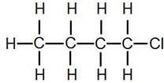
Chemistry Topic 10 – Acids, bases, pH
At GCSE you will know that an acid can dissolve in water to produce H+ ions, at A level you will need a greater understanding of what an acid or a base is.
Read the following page and answer the questions

http://bit.ly/pixlchem15 http://www.chemguide.co.uk/physical/acidbaseeqia/theories.html#top

Q1. What is your new definition of what an acid is? Q2. How does ammonia (NH3) act as a base?

http://bit.ly/pixlchem16 http://www.chemguide.co.uk/physical/acidbaseeqia/acids.html#top

Q3 Ethanoic acid (vinegar) is a weak acid, what does this mean?
Q4 What is the pH of a solution of 0.01 moldm-3 of the strong acid, hydrochloric acid?
Chemistry Topic 9 – Organic chemistry – functional groups
At GCSE you would have come across hydrocarbons such as alkanes (ethane etc) and alkenes (ethene etc). You may have come across molecules such as alcohols and carboxylic acids. At A level you will learn about a wide range of molecules that have had atoms added to the carbon chain. These are called functional groups, they give the molecule certain physical and chemical properties that can make them incredibly useful to us.
Here you are going to meet a selection of the functional groups, learn a little about their properties and how we give them logical names.
You will find a menu for organic compounds here:

http://bit.ly/pixlchem13 http://www.chemguide.co.uk/orgpropsmenu.html#top

And how to name organic compounds here:
http://bit.ly/pixlchem14 http://www.chemguide.co.uk/basicorg/conventions/names.html#top

Using the two links see if you can answer the following questions:
Q1. Halogenoalkanes
- What is the name of this halogenoalkane?
- How could you make it from butan-1-ol?
Q2. Alcohols
- How could you make ethanol from ethene?
- How does ethanol react with sodium and in what ways is this a) similar to the reaction with water, b) different to the reaction with water?
Q3. Aldehydes and ketones
- Draw the structures of a) propanal, b) propanone
- How are these two functional groups different?


If you are on holiday in the UK, or on a staycation at home, why not plan a day trip to one of these :

Glasgow Science Centre - Glasgow
Dundee Science Centre - Dundee

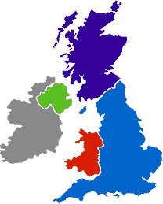W5 - Belfast

Colour Experience - Bradford

Catalyst Discovery Centre - Widnes

Black Country Living Museum - Dudley
Think-tank - Birmingham

National Museum - Cardiff

Cambridge Science Centre - Cambridge

The Whipple Museum - Cambridge

Bristol Science
Centre - Bristol
The Faraday Museum
- London

Science on Social Media


Science communication is essential in the modern world and all the big scientific companies, researchers and institutions have their own social media accounts. Here are some of our top tips to keep up to date with developing news or interesting stories:
Follow on Twitter:
Satlers’ Institute - Our activities include Festivals of Chemistry; Chemistry Camps; Curricula; Awards for Technicians, Graduates, A Level Students; and Seminars
@salters_inst

Daily A Level Chemistry Facts – Daily Chemistry Facts (Based on the A-Level AQA spec but most facts work with all)
@chemAlevels

Chemistry News –The latest chemistry news from only the best sources @chemistrynews

Compound Interest– Graphics exploring everyday #chemistry. Winner of @absw 2018 science blog award
@compoundchem

Chemistry World – Chemistry magazine bringing you the latest chemistry news and research every day. Published by the Royal Society of Chemistry.
@ChemistryWorld

Royal Society of Chemistry - Promote, support and celebrate chemistry. Follow for updates on latest activities
@RoySocChem

Periodic Videos– Chemistry video series by @BradyHaran & profs at the Uni of Nottingham - also see @sixtysymbols & @numberphile
@periodicvideos
Find on Facebook:
Science Now - Science Now is a dedicated community that helps spread science news in all fields, from physics to biology, medicine to nanotechnology, space and beyond!

National Science Foundation – As an independent federal agency, NSF fund a significant proportion of basic research. For official source information about NSF, visit www.nsf.gov

Science News Magazine - Science covers important and emerging research in all fields of science

BBC Science News - The latest BBC Science and Environment News: breaking news, analysis and debate on science and nature around the world

Scientific American - Scientific American is the authority on science and technology for a general audience, with coverage that explains how research changes our understanding of the world and shapes our lives.

These websites all offer an amazing collection of resources that you should use again and again through out your course.

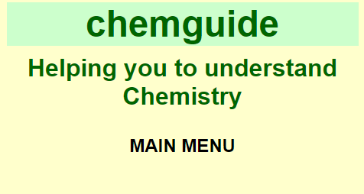
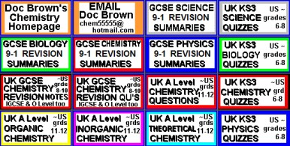
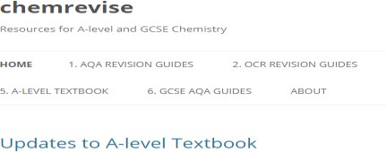

This website is very detailed and identifies other resources which are sharing incorrect or outdated information and suggests the correct materials to use. The site also contains links to the syllabuses of many exam boards which means it is accessible and useful to all students. https://www.chemguide.co.u k/



The free revision website for students studying GCSE and A- levels. S-cool provides revision guides, question banks, revision timetable and more https://www.s-cool.co.uk/a- level/chemistry

Doc Brown is a website dedicated to all three science subjects; physics, chemistry and biology. It provides the user with summarised notes (useful for making flash cards) and practice questions to further their knowledge and understanding.
The site provides resources from a wide range of exam boards including AQA, Edexcel, Chemistry, CCEA, OCR, WJEC, CIE and Salters from GCSE level to A2. http://www.docbrown.info/

The site was first made to host revision guides that are written for AQA A-level Chemistry. These revision guides have already been circulating on the internet for a couple of years on places like student room. This will be the place for the most up to date versions of them. The site has now extended to cover other exam boards. (OCR and Edexcel) https://chemrevise.org/



Tons of awesome courses in one awesome channel! Check out the playlists for past courses in physics, philosophy, games, economics, U.S. government and politics, astronomy, anatomy & physiology, world history, biology, literature, ecology, chemistry, psychology, and of course, chemistry! https://www.youtube.com/user/crash course/featured


Want to stand above the rest when it comes to UCAS? Now is the time to act.
MOOCs are online courses run by nearly all universities. They are short FREE courses that you take part in. They are usually quite specialist, but aimed at the public, not the genius!
There are lots of websites that help you find a course, such as edX and Future learn.
You can take part in any course, but there are usually start and finish dates. They mostly involve taking part in web chats, watching videos and interactives.
Day 4 of the holidays and boredom has set in?
There are loads of citizen science projects you can take part in either from the comfort of your bedroom, out and about, or when on holiday. Wikipedia does a comprehensive list of all the current projects taking place. Google ‘citizen science project’



Completing a MOOC will look great on your Personal statement and they are dead easy to take part in!

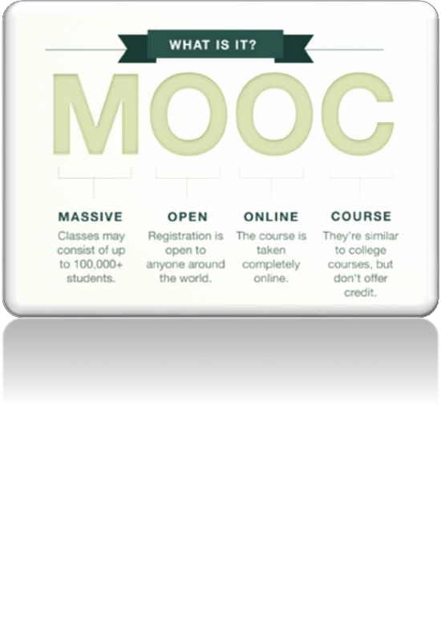
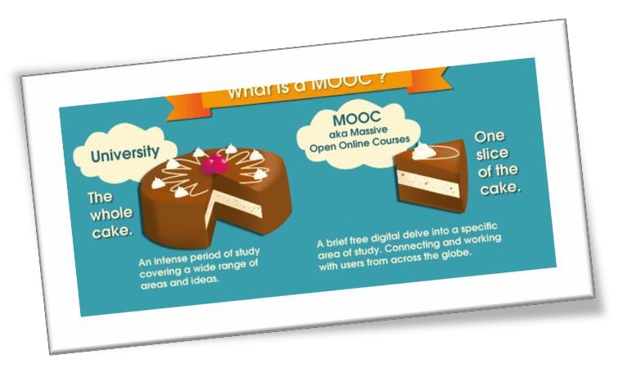

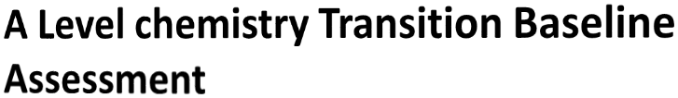
The following 40 minute test is designed to test your recall, analysis and evaluative skills and knowledge.
Remember to use your exam technique: look at the command words and the number of marks each question is worth. A suggested mark scheme is provided for you to check your answers.

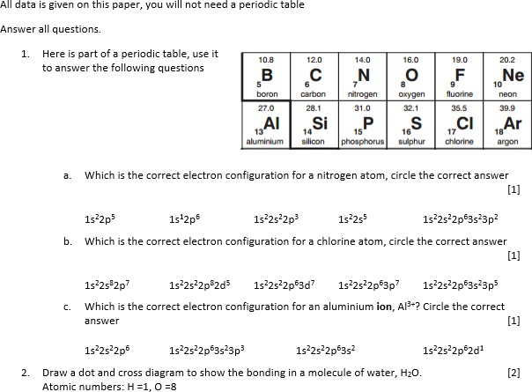

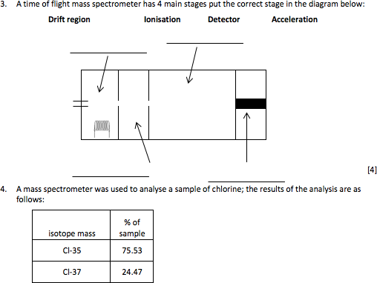

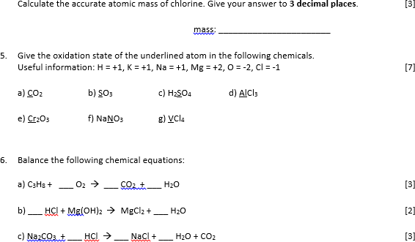

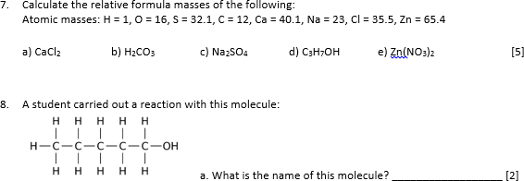

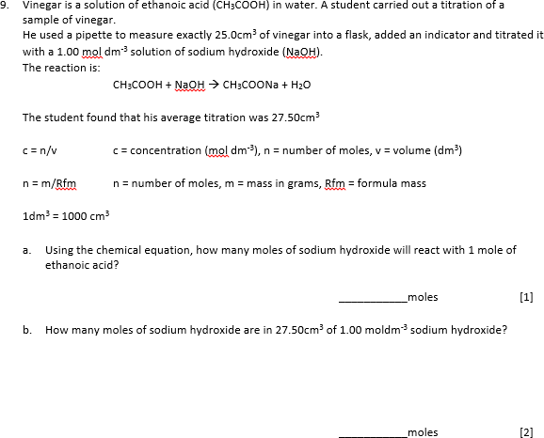

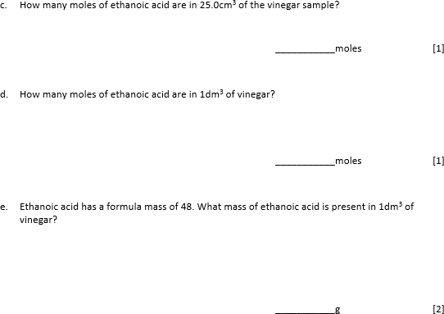

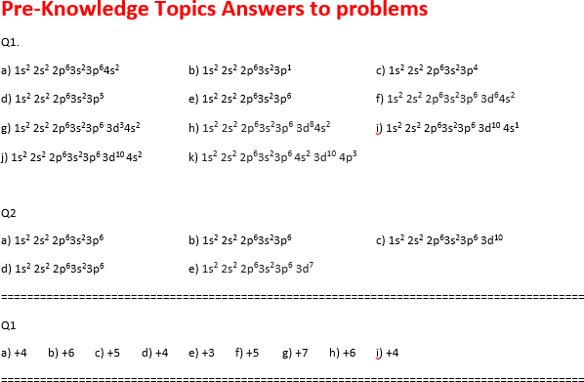

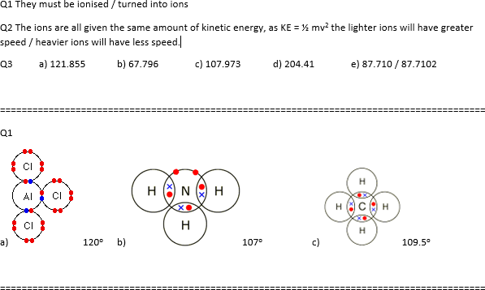

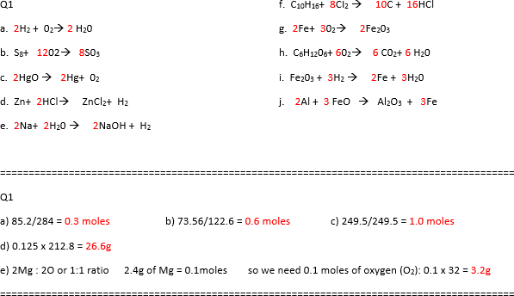

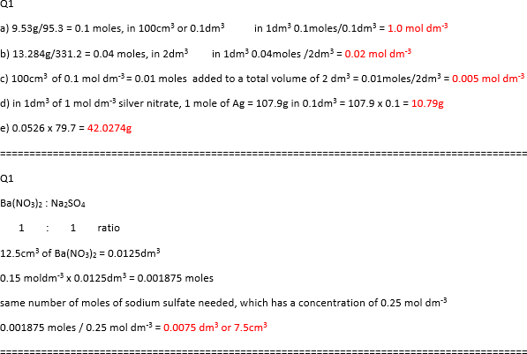

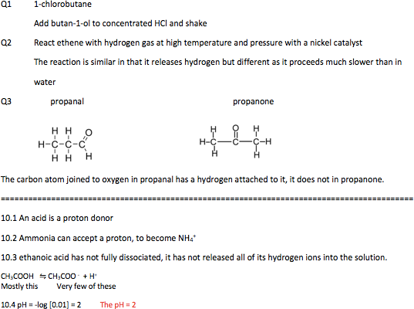

Suggested Mark Scheme:
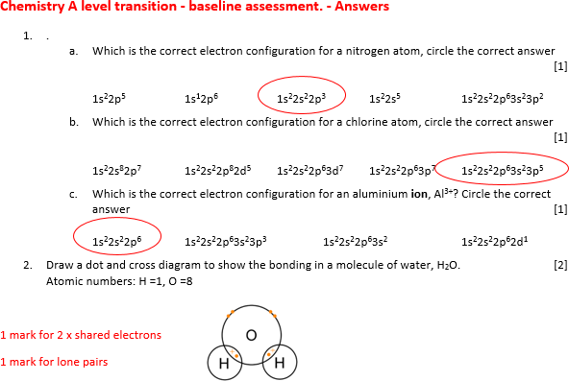

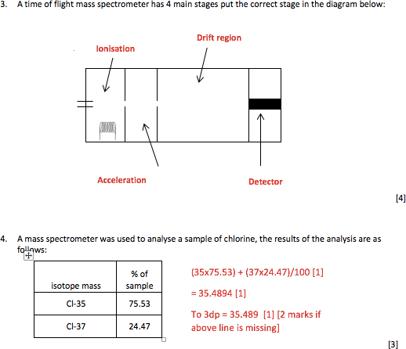

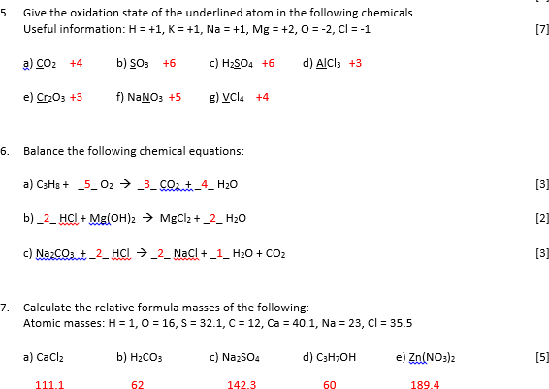

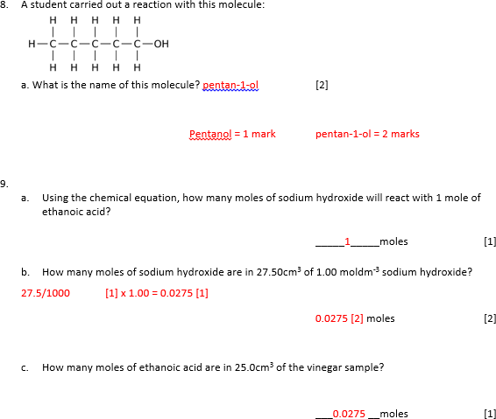

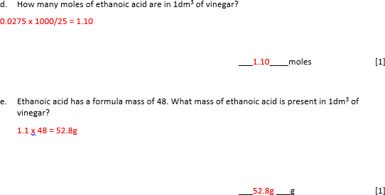

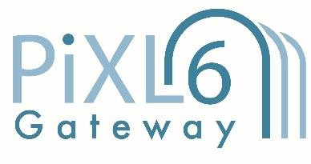

© The PiXL Club Ltd. June 2018
This resource is strictly for the use of member schools for as long as they remain members of The PiXL Club. It may not be copied, sold, or transferred to a third party or used by the school after membership ceases. Until such time it may be freely used within the member school.

All opinions and contributions are those of the authors. The contents of this resource are not connected with, or endorsed by, any other company, organisation or institution.

PiXL Club Ltd endeavour to trace and contact copyright owners. If there are any inadvertent omissions or errors in the acknowledgements or usage, this is unintended and PiXL will remedy these on written notification.

